**

DRAFT REPORT – R0

*Fiscal Years 2018-2020*

MATC YeAR TWO rEport

Submitted by

Michael Sweigard

Graduate Research Assistant

Cody Stolle

Research Assistant Professor

Ricardo Jacome

Graduate Research Assistant

MIDWEST ROADSIDE SAFETY FACILITY

Nebraska Transportation Center

University of Nebraska-Lincoln

**Main Office**

Prem S. Paul Research Center at Whittier School

Room 130, 2200 Vine Street

Lincoln, Nebraska 68583-0853

(402) 472-0965

**Outdoor Test Site**

4630 NW 36th Street

Lincoln, Nebraska 68524

Submitted to

MID-AMERICA TRANSPORTATION CENTER

2200 Vine Street

Lincoln, Nebraska 68583

MwRSF Research Report No. MwRSF-40042-01

September 19, 2019

|  |  |  |  |  |  |
| --- | --- | --- | --- | --- | --- |
| TECHNICAL REPORT DOCUMENTATION PAGE | | | | | |
| 1. Report No. | 2. | | | 3. Recipient’s Accession No. | |
| MwRSF-40042-01 |  | | |  | |
| 4. Title and Subtitle | | | | 5. Report Date | |
| MATC Year Two Report | | | | September 19, 2019 | |
| 6. | |
|  | |
| 7. Author(s) | | | | 8. Performing Organization Report No. | |
| Sweigard, M.E., Jacome, R.O., and Stolle, C.S. | | | | MwRSF-40042-01 | |
| 9. Performing Organization Name and Address | | | | 10. Project/Task/Work Unit No. | |
| Midwest Roadside Safety Facility (MwRSF)  Nebraska Transportation Center  University of Nebraska-Lincoln | | | |  | |
| Main Office:  Prem S. Paul Research Center at Whittier School  Room 130, 2200 Vine Street  Lincoln, Nebraska 68583-0853 | | Outdoor Test Site:  4630 NW 36th Street  Lincoln, Nebraska 68524 | | 11. Contract (C) or Grant (G) No. | |
|  | |
| 12. Sponsoring Organization Name and Address | | | | 13. Type of Report and Period Covered | |
| Mid-America Transportation Center  220 Vine Street  Lincoln, Nebraska 68583 | | | | Draft Report: 2017-2018 | |
| 14. Sponsoring Agency Code | |
|  | |
| 15. Supplementary Notes | | | | | |
| Prepared in cooperation with U.S. Department of Transportation, Federal Highway Administration. | | | | | |
| 16. Abstract | | | | | |
| Previous efforts to develop a “Virtual Barrier” System that assists on vehicle navigation, resulted in the first phase of the MATC Smart Barrier project. In phase one, a literature review was performed to come up with a feasible solution to make safer roads. Current intelligent technology was investigated to learn about the current status of technology and evaluate potential system gaps and flaws to develop a supplementary system.  The second phase of this project proposes a novel method to offer an extra level of redundancy to current vehicle guidance systems. The method is separated into three main steps denoted as: Local Path Generation, Local Positioning, and Vehicle Guidance/Warning. The method as a whole is explained, followed by a detailed explanation on how Path Generation and Vehicle Guidance System will work. In general Path Generation techniques are used to provide road guidance information to vehicles wirelessly. The guidance information is collected offline to develop a local road database. Vehicle Guidance System focuses on the developed of a control system based on the road data to be used as a driver warning system by developing various metrics to help better predict potential road departure and vehicle instability situations. The data is also used to develop an autonomous guidance structure for typical and emergency driving scenarios. These together offer a method that will be used in prototyping on the third phase of this project. | | | | | |
| 17. Document Analysis/Descriptors | | | 18. Availability Statement | | |
| Highway Safety, Run off road crashes, Path Prediction, Vehicle Controls, Inter-Vehicle Communication, Traffic Management | | | No restrictions. Document available from: National Technical Information Services, Springfield, Virginia 22161 | | |
| 19. Security Class (this report) | 20. Security Class (this page) | | 21. No. of Pages | | 22. Price |
| Unclassified | Unclassified | | 60 | |  |

DISCLAIMER STATEMENT

This report was completed with funding from the Mid-American Transportation Center. The contents of this report reflect the views and opinions of the authors who are responsible for the facts and the accuracy of the data presented herein. The contents do not necessarily reflect the official views or policies of the Mid-American Transportation Center. This report does not constitute a standard, specification, regulation, product endorsement, or an endorsement of manufacturers.

ACKNOWLEDGEMENTS

The authors wish to acknowledge several sources that made a contribution to this project: (1) Mid-America Transportation Center.; (2) Richard Stepp at Florida DOT; (3) David Boruff at Indiana DOT.

Acknowledgement is also given to the following individuals who made a contribution to the completion of this research project.

**Midwest Roadside Safety Facility**

R.K. Faller, Ph.D., P.E., Research Associate Professor & MwRSF Director

J.D. Reid, Ph.D., Professor

J.D. Schmidt, Ph.D., P.E., Research Assistant Professor

J.C. Holloway, M.S.C.E., E.I.T., Test Site Manager

K.A. Lechtenberg, M.S.M.E., E.I.T., Research Engineer

R.W. Bielenberg, M.S.M.E., E.I.T., Research Engineer

S.K. Rosenbaugh, M.S.C.E., E.I.T., Research Engineer

M. Asadollahi Pajouh, Ph.D., Former Post-Doctoral Research Assistant

S.A. Ranjha, Ph.D., Former Post-Doctoral Research Assistant

A.T. Russell, B.S.B.A., Testing and Maintenance Technician II

F. Bai, Ph.D. Post-Doctoral Research Assistant

S.M. Tighe, Construction and Testing Technician I

D.S. Charroin, Construction and Testing Technician I

M.A. Rasmussen, Construction and Testing Technician I

E.W. Krier, Construction and Testing Technician II

M.T. Ramel, Construction and Testing Technician I

R.M. Novak, Construction and Testing Technician I

J.E. Kohtz, B.S.M.E., CAD Technician

E.L. Urbank, B.A., Research Communication Specialist

Undergraduate and Graduate Research Assistants

|  |  |  |  |  |
| --- | --- | --- | --- | --- |
| SI* (MODERN METRIC) CONVERSION FACTORS | | | | |
| **APPROXIMATE CONVERSIONS TO SI UNITS** | | | | |
| **Symbol** | **When You Know** | **Multiply By** | **To Find** | **Symbol** |
| **LENGTH** | | | | |
| in. | inches | 25.4 | millimeters | mm |
| ft | feet | 0.305 | meters | m |
| yd | yards | 0.914 | meters | m |
| mi | miles | 1.61 | kilometers | km |
| **AREA** | | | | |
| in2 | square inches | 645.2 | square millimeters | mm2 |
| ft2 | square feet | 0.093 | square meters | m2 |
| yd2 | square yard | 0.836 | square meters | m2 |
| ac | acres | 0.405 | hectares | ha |
| mi2 | square miles | 2.59 | square kilometers | km2 |
| **VOLUME** | | | | |
| fl oz | fluid ounces | 29.57 | milliliters | mL |
| gal | gallons | 3.785 | liters | L |
| ft3 | cubic feet | 0.028 | cubic meters | m3 |
| yd3 | cubic yards | 0.765 | cubic meters | m3 |
| 1. NOTE:volumes greater than 1,000 L shall be shown in m3 | | | | |
| **MASS** | | | | |
| oz | ounces | 28.35 | grams | g |
| lb | pounds | 0.454 | kilograms | kg |
| T | short ton (2,000 lb) | 0.907 | megagrams (or “metric ton”) | Mg (or "t") |
| **TEMPERATURE (exact degrees)** | | | | |
| °F | Fahrenheit | 5(F-32)/9  or (F-32)/1.8 | Celsius | °C |
| **ILLUMINATION** | | | | |
| fc | foot-candles | 10.76 | lux | lx |
| fl | foot-Lamberts | 3.426 | candela per square meter | cd/m2 |
| **FORCE & PRESSURE or STRESS** | | | | |
| lbf | poundforce | 4.45 | newtons | N |
| lbf/in2 | poundforce per square inch | 6.89 | kilopascals | kPa |
| **APPROXIMATE CONVERSIONS FROM SI UNITS** | | | | |
| **Symbol** | **When You Know** | **Multiply By** | **To Find** | **Symbol** |
| **LENGTH** | | | | |
| mm | millimeters | 0.039 | inches | in. |
| m | meters | 3.28 | feet | ft |
| m | meters | 1.09 | yards | yd |
| km | kilometers | 0.621 | miles | mi |
| **AREA** | | | | |
| mm2 | square millimeters | 0.0016 | square inches | in2 |
| m2 | square meters | 10.764 | square feet | ft2 |
| m2 | square meters | 1.195 | square yard | yd2 |
| ha | hectares | 2.47 | acres | ac |
| km2 | square kilometers | 0.386 | square miles | mi2 |
| **VOLUME** | | | | |
| mL | milliliter | 0.034 | fluid ounces | fl oz |
| L | liters | 0.264 | gallons | gal |
| m3 | cubic meters | 35.314 | cubic feet | ft3 |
| m3 | cubic meters | 1.307 | cubic yards | yd3 |
| **MASS** | | | | |
| g | grams | 0.035 | ounces | oz |
| kg | kilograms | 2.202 | pounds | lb |
| Mg (or "t") | megagrams (or “metric ton”) | 1.103 | short ton (2,000 lb) | T |
| **TEMPERATURE (exact degrees)** | | | | |
| °C | Celsius | 1.8C+32 | Fahrenheit | °F |
| **ILLUMINATION** | | | | |
| lx | lux | 0.0929 | foot-candles | fc |
| cd/m2 | candela per square meter | 0.2919 | foot-Lamberts | fl |
| **FORCE & PRESSURE or STRESS** | | | | |
| N | newtons | 0.225 | poundforce | lbf |
| kPa | kilopascals | 0.145 | poundforce per square inch | lbf/in2 |
| *SI is the symbol for the International System of Units. Appropriate rounding should be made to comply with Section 4 of ASTM E380. | | | | |

TABLE OF CONTENTS

TECHNICAL REPORT DOCUMENTATION PAGE i

DISCLAIMER STATEMENT i

ACKNOWLEDGEMENTS i

SI* (MODERN METRIC) CONVERSION FACTORS i

1 INTRODUCTION 1

1.1 Problem Statement 1

1.2 Objective 1

1.2.1 Overall Objective 1

1.2.2 Scope 1

1.3 Year 2 Scope 1

2 Technology Review 1

2.1 Current Technology 1

2.2 Complementary Solution (MATC Smart Barrier) 1

3 MATC BARRIER: METHOD OVERVIEW 1

3.1 Objectives 1

3.2 Assumptions 1

3.3 Preview Concept 1

4 ZEROTH STEP: LOCAL PATH GENERATION 1

4.1 Problem Statement 1

4.2 Trajectory Generation Background 1

4.2.1 Traditional Methods for Trajectory Generation 1

4.2.1.1 Euler-Lagrange General Formulation 1

4.3 Trajectory Criteria 1

4.3.1 Problem Solution 1

4.4 Mathematical Formulation 1

4.4.1 Heading Angle Integration Formulation 1

4.4.2 Heading Angle Orthogonal Shift 1

4.5 Road Slicing 1

4.5.1 AASHTO Base Model 1

4.5.2 Google Earth Model 1

5 SECOND STEP: VEHICLE GUIDANCE/WARNING 1

5.1 Problem Statement 1

5.2 Introduction 1

5.3 Driver Assistance Literature Review 1

5.4 Driver Warning System Development 1

5.4.1 Requirements 1

5.4.2 Vehicle instabilities 1

5.4.2.1 Excessive Speed 1

5.4.2.2 Roll Over 1

5.4.3 Departure Thresholds 1

5.4.3.1 Orientation Error 1

5.4.3.2 Rate of change of heading angle 1

5.4.3.3 Change in acceleration 1

5.4.3.4 Lateral Deviation 1

5.5 Safe Stop Scenarios 1

5.6 Emergency Stop Evaluation 1

5.7 Threshold Summary 1

5.8 Vehicle control literature review 1

5.8.1 Control methods 1

5.8.1.1 PID Control 1

5.8.1.2 MPC Control 1

5.8.2 Correction Methods 1

5.8.2.1 Stanley method 1

5.8.2.2 Pure Pursuit 1

5.9 Vehicle control development 1

5.9.1 Road Model 1

5.9.2 Vehicle Model 1

5.9.3 Model Development 1

5.10 Results of Simulation 1

5.10.1 Standard Control Scenario 1

5.10.2 Emergency Stop Control 1

6 SUMMARY AND FUTURE WORK 1

6.1 Summary 1

6.1.1 Path Generation 1

6.1.2 Vehicle Control 1

7 REFERENCES 1

8 APPENDICES 1

Appendix A. Euler-Lagrange General Formulation 1

LIST OF FIGURES

Figure 1 Examples of ROR Crashes (images take from NHTSA’s NASS CDS) 1

Figure 2 Fiver Year Plan 1

Figure 3 Vehicle Sensors [8] 1

Figure 4 MATC SMART Barrier Concept 1

Figure 5 Navigation-Correction Scheme 1

Figure 6 Different Trajectories in a Given Path from Point A to Point B 1

Figure 7 Normal-Tangential Coordinates Along a Curve 1

Figure 8 Circumscribed Circle in Scalene Triangle 1

Figure 9 Circumscribed Circle with Unit Vector 1

Figure 10 Circumscribed Circle with Unit Vectors and 1

Figure 11 Triangles Formed through Intersections of Unit Vectors 1

Figure 12 Scalene Triangle in Arc-Segment 1

Figure 13 Road Section with Discrete Sections 1

Figure 14 AASHTO Base Model: Road with Curvature Vectors 1

Figure 15 AASHTO Base Model: Curvature κ vs. Cumulative Curve Length 1

Figure 16 AASHTO Base Model: Orthogonal Phase Shift Approach 1

Figure 17 AASHTO Base Model: Numerical Integration Approach 1

Figure 18 AASHTO Base Model: Road with Velocity Vectors 1

Figure 19 Google Earth Model: Road with Curvature Vectors 1

Figure 20 Google Earth Model: Curvature κ vs. Cumulative Curve Length 1

Figure 21 Google Earth Model: Orthogonal Phase Shift Approach 1

Figure 22 Google Earth Model: Road with Velocity Vectors 1

Figure 23 Track Width Vehicle Model 1

Figure 24 Heading Error and Lateral Deviation 1

Figure 25 Departure Rate According to Heading Angle Error 1

Figure 26 Lateral Position over Time 1

Figure 27 Orientation Angle over Time 1

Figure 28 Example of MPC Prediction and Control [49] 1

Figure 29 Pure Pursuit Controller Geometry [50] 1

Figure 30 Road Data XY Data 1

Figure 31 Road Curvature Data 1

Figure 32 Heading Angle Data 1

Figure 33 Bicycle Model 1

Figure 34 Vehicle Control Schematic 1

Figure 35 Road Curvature vs. Time 1

Figure 37 Wheel Angle Error from Current Desired Wheel Angle 1

Figure 38 Wheel Angle Inputs 1

Figure 39 Lateral Acceleration over Time 1

Figure 40 Wheel Angle Inputs for Emergency Stop 1

Figure 41 Lateral Error during Emergency Stop 1

LIST OF TABLES

Table 1 Controller Parameters 1

Table 2 Emergency Stop Control Parameters 1

1 INTRODUCTION

* 1. Problem Statement

The Federal Highway Administration (FHWA) reported that approximately 53% of fatal crashes (18,779) between 2014 and 2016 were related to roadside departures or lane departures [1]. Overall, approximately 1/3 of more than 30,000 annual traffic fatalities are attributable to run-off-road (ROR) crashes. It can be seen from these statistics that these types of accidents account for a large percentage for fatal accidents on the road.

Most of these crashes can be categorized into the following: drift off road, overcorrection, failure to negotiate curve, and avoidance maneuver.

* Drift Off Road: vehicle slowly departs roadway, typically at a small angle of departure and straight-line trajectory. This condition is commonly associated with drowsy or impaired drivers, or drivers who experience disabling medical problems.
* Overcorrection: the vehicle experiences a path change (drift out of lane, lane change, avoidance maneuver), then the driver overcompensates while attempting to guide the vehicle back to the desired lane. This roadside departure type commonly results in spinout and skidding.
* Failure to Negotiate Curve: vehicle veers to the outside of a curve. Condition is frequently associated with high travel speeds or poor pavement friction (e.g., ice).
* Avoidance Maneuver: vehicle performs evasive maneuver to avoid crashing into an object, person, or animal in lane. This roadside departure condition is commonly associated with higher travel speeds (e.g., freeway), and is abrupt and panicked.

Examples of these categories can be seen in Figure 1.

|  |  |
| --- | --- |
| 134002987--tree--scene  (a) Drift-Off Road | 134002687--tree--scene  (b) Overcorrection / Oversteering |
| 134003225-trj-rotated  (c) Failure to Negotiate Curve | 146000714--avoidance-stalled-vehicle  (d) Avoidance Maneuver |

Figure 1 Examples of ROR Crashes (images take from NHTSA’s NASS CDS)

New technology is installed in modern vehicles to help reduce the frequency of ROR excursions. Advanced driver-assistance systems (ADAS) assist the driver by identifying the geometry of the road using lane markings and warning or proactively intervening if the vehicle encroaches on a lane edge [2-4]. However these systems are subject to considerable limitations due weather, lighting, false positives, or the lack of road markings. This lead

* 1. Objective

The objective of this project is to develop a vehicle-to-infrastructure (V2I) system which can assist the vehicle in remaining on the roadway.

* + 1. Scope

This research study corresponds to Year 1 of the Smart Barrier project. To complete Year 1 objectives, researchers performed an extensive literature review, including a summary of vehicle sensors and filtering techniques, vehicle control techniques, and modern Advanced Driver Assist Systems (ADAS). This summary report describes the findings from Year 1.

The second year of the project will involve modeling various part of the overall system including vehicle controls, vehicle dynamics and road geometry modeling. Year three will include the validation of modeling done in year two and continuous updating and finalizing the model. Year four will begin prototyping and compiling hardware to implement the system. Year five of the project will involve testing the full system and assembling the results. Outlined in this report is the results of the first year’s results.

Figure Five Year Plan

* 1. Year 2 Scope

The organization of this report focuses on explaining a new method to provide vehicle guidance utilizing V2I communication.

* Chapter 2 of this report offers a background section summarizing the year 1 report with major findings regarding the current state of transportation technology. After the conclusion of the background research, a new method for providing guidance parameters for autonomous technology is offered.
* Chapter 3 describes a basic overview of this method, along with how it would be used in real operations. The overall method can be categorized into three distinct sections. These sections are explained and a list of objectives for the overall system is given for evaluation criteria of the system.
* Chapter 4 contains a detailed explanation of the first section for the project. This section is known as Local Path Generation, which consists of developing offline data based on a various data collection sources.
* Chapter 5 goes into the second section of the project known as Localization/Communication. The main focus of this chapter is to offer general communication strategies and a proposed system implementation that is compatible with the methods disclosed in Chapter 4.
* Chapter 6 is the third section of the project called Vehicle Guidance/Warning, which details the development of a controller for an autonomous vehicle that uses information provided from Chapter 4. This section delves into the intricacies of implementing a warning/guidance system with a simulated vehicle controller.
* Chapter 7 summarizes the system development progress and findings in its entirety and discusses further research that needs to be accomplished.
* Chapter 8 entails a discussion of proposed plans for year three of the project.

1. Technology Review
   1. Current Technology

Autonomous vehicles can be classified into different levels of autonomy based on the scope of responsibility dedicated to the vehicle computer. The SAE has published a set of autonomy levels in *SAE Recommended Practice J306 2018.* These levels of autonomy are based on the responsibility of Dynamic Driving Tasks (or DDT). DDTs can be classified into two main tasks: Longitudinal DDTs and Lateral DDTs. Longitudinal DDTs focuses on controlling the brake and throttle to maintain speeds and prevent crashes. Lateral DDTs involve maintaining the desired vehicle travel direction by modulating braking and steering which range from simple guidance on the road and evolve to avoidance for emergency maneuvering. DDTs can be performed by either a human driver or an autonomous controller in the vehicle. The more DDT tasks that the vehicle controller is responsible for, the higher the autonomy level. In general, from levels 0 through 2, a human driver performs all DDTs. From levels 3 through 5, a controller takes over a greater percentage of DDTs such that at level 5 autonomy the vehicle is 100% independent of the driver. Currently, no level 5 autonomy vehicle exists on the current market [5].

The level of autonomy depends heavily on the type of sensors a vehicle has onboard. These sensors were discussed previously [6]. A simple overview of the main sensors in a vehicle is shown in Figure 3. These sensors can be used for two main functions: localization and environment recognition. Environment recognition can be in the form of light sensors, or ultrasound sensors. Localization sensors are usually Global Positioning Systems. Environment recognition sensors tend to be inefficient depending many factors such as the amount of brightness, the quality of paint in lane markings, and background information that can blend into images. Furthermore, weather disruptions have proven image recognition from light sources to be deceptive. For positioning, GPS has presented a degree of error around 6 feet which is enough to misplace a vehicle in a different lane [7].

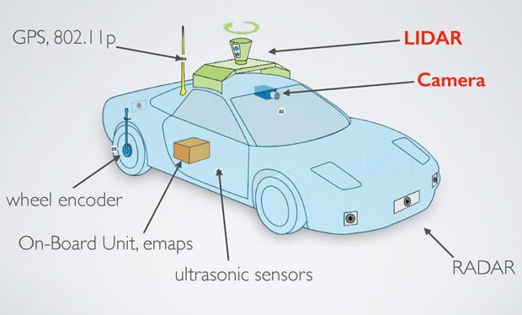

Figure Vehicle Sensors [8]

In recent years, infrastructure has been used as a new medium for providing more information to autonomous vehicles. For example, V2I communication have been expanding as a new area of research in the transportation field. This technology has been used to provide traffic flow data to vehicles that come from a station monitoring current state of traffic during any given day. As of today, this technology is still in development and being tested by Department of Transportation (DOT) facilities.

* 1. Complementary Solution (MATC Smart Barrier)

Based on the information collected from MATC Phase 1 report, it was concluded that in order to achieve true level 5 of autonomy, more improvements are needed. Currently, there are many areas of research that focus on developing different categories of this technology, mainly related to vehicle sensor based data acquisition. We wish to propose as system that is not solely dependent of the information gather by vehicle systems but utilizes external road data information to guide the vehicle.

The solution that we propose to supplement current vehicle technology is to create a vehicle to infrastructure communication (V2I) system. This method allows for verified information regarding the roadway geometry ahead to be sent to the vehicle. This is independent of the vehicle sensors and is not affected by some of the same disturbances that plague vehicle sensors.

This system is not intended to completely replace existing vehicle guidance systems as it is not meant to envelop all aspects of vehicle travel. This system does not have the capability to account for the randomness that can be attributed to other characters on the roadway such as pedestrians, animals, and human controlled vehicles. The main purpose of this system is to provide the necessary information to the vehicle so that it may reliably stay on the road. Instead of replacing technology is meant to strengthen current systems but to serve as an additional level a redundancy to fill in existing gaps and serve as an official reference point.

1. MATC BARRIER: METHOD OVERVIEW

Given the current state of technology for autonomous vehicles, it has been observed that in order to evolve towards a more reliable and fully functional system additional data is need, independent of onboard vehicle environmental detection sensors. A method involving infrastructure technology is proposed to provide a new level of redundancy to elevate the functionality of vehicle technology. The method consists of three sections denoted as: Local Path Generation, Localization/Communication and Vehicle Guidance/Warning. The proposed method aims to identify geometries of travel lanes and develop a target path, independent of the vehicle. The system will also triangulate the vehicle’s position, and transmit the aforementioned path data to the vehicle for both immediate and future paths. Based on the information that the vehicle receives, is utilized by the vehicle to safely navigate the prescribed path.

* 1. Objectives

In the development of a method, a series of objectives were created to evaluate the feasibility of each of the three sections and the implementation of them to determine to best overall solution. The objectives for the overall system focuses on the efficiency of road geometry mapping, vehicle control for error minimization, and transmission options.

Selecting a proper road geometry mapping method will was based on a variety of evaluation criteria. The data that is being transmitted to the vehicle needs to be comprehensive enough to provide necessary information so the vehicle can stay on the roadway. Additionally the data that is transmitted cannot be cumbersome such that the data packets require a significant amount of transmission bandwidth and take time for the vehicle computer to process. The data also needs to reliable in all environments and conditions so that the vehicle can effectively navigate the roadway at all times. The method needs to work with all types of vehicles, as long as they have the necessary hardware to receive the data. Lastly, the goal project is to develop a method that can be used in every corner of the country, therefore the method chosen must able to realistically installed and maintained with a reasonable amount of cost to the public and monitoring agencies.

The transmission type is primarily dependent on the road geometry method that is chosen. It needs to be able to handle whatever kind of data is chosen and be able to consistently and accurately send the data to every vehicle on the road. Therefore the transmission structure needs to also work in all environments and conditions. It needs to be able to sync up with in-range vehicles and send the appropriate data quickly. The desire is to minimize the amount of hardware needed to reduce cost and to reduce the frequency at which vehicles need to disconnect and re-connect with new transmission stations. The infrastructure also needs to be able to be secured against false data and interference from people who desire to disrupt the system. The transmission infrastructure will also serve as means to triangulate the vehicle position when needed, to provide in-lane accuracy to the vehicles to keep it securely on the road.

A vehicle control and stability system also needs to be developed to verify that the information sent to the vehicle can be successfully used to navigate the given roadway. An additional objective of the control algorithm is to help minimize that amount of data transmission needed so the information is not overload the network. The control algorithm needs to work in two parts. First it must be able to serve as a driver assistance system to warn the driver that the vehicle is trending off of the road or the vehicle has left the road. Secondly as am autonomous navigation tool to operate without the involvement of a human driver. In future phases of the project it will be used as the basis for a proof of concept prototype.

* 1. Assumptions

To develop this method, the following assumptions need to be stated:

1. The vehicle possesses the necessary technology to receive the data transmission from the infrastructure network and to also self-navigate by controlling the steering, acceleration and braking independent of the driver.
2. We assume that there are no random abnormalities in the road environment that would adversely affect a vehicles type trajectory along the roadway such as potholes, animals crossing, or construction zones.
3. We assume that the data used, road data and positioning data, is 100% accurate and there are no issue transmitting or receiving any of the data. This is done to focus purely on the formula and use of the data itself.

The project expects to expand for different vehicle types and to include different levels of disturbances such as including construction zones, vehicle dynamic effects, weather and other effects. However, this project focuses on the basis of developing the basic method before delving in higher degrees of disturbances.

* 1. Preview Concept

As previously mentioned the method is partitioned into three different sections. Before we deep dive into each section individually we first give an explanation of the overview of the system and how it would operate its physical implementation. An overview of the complete steps is shown on Figure XX.

The zeroth step involves obtaining a roadway geometry for a given path. This step is performed before any communication or guidance takes place and is independent from the performance of steps 1 and 2. Using the method disclosed later in this report, data regarding the road path is collected, optimized and then stored in the infrastructure network. Any modifications to the physical road geometry, or upgrades to the physical road changes would invoke an update to the data banks as well. However, these modifications would be occurring at a much lower frequency (e.g. months/years), compared the other methods (e.g. seconds).

Step 1 involves localizing the vehicle to given coordinate system, and sending the relevant road data that is previously calculated and stored in step 0. To send the information, transmission stations will optimally positioned to send the necessary information to the vehicle, but this data transmission method is will not be discussed on this report. This process begins with localizing the vehicle on the roadway. After a position has been established, information will be sent to every upcoming vehicle that comes into the range of the station. This continuous cycle of localization, transmission, driving, and repeating will be occurring for all required traveling distance. This step requires constant monitoring and continuous maintenance for both hardware and software.

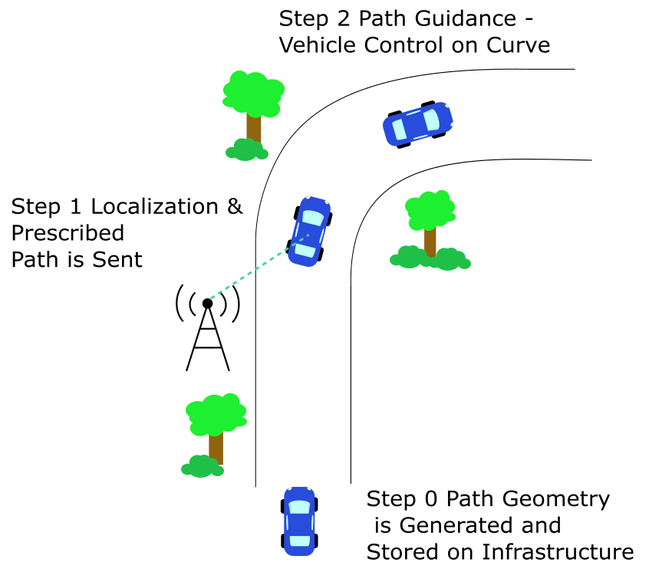

Figure MATC SMART Barrier Concept

Step 2 involves using the data obtained from step 0 and localization from step 1 to correct and navigate safely throughout the path. This is performed with an on-board vehicle controller which is able to adjust throttle, steering or braking to be able to maneuver road curves properly. The hardware technology for this step is usually already installed in the vehicles as per previous assumptions. Figure XX shows an example of the type of information the vehicle is receiving and how the controller tries to redirect itself back to the road.

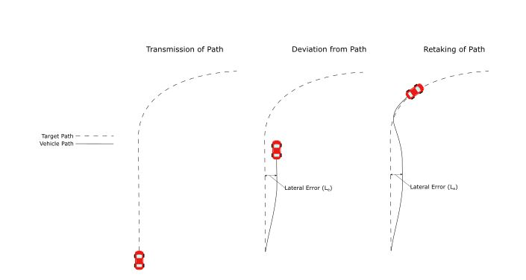

Figure Navigation-Correction Scheme

1. ZEROTH STEP: LOCAL PATH GENERATION
   1. Problem Statement

The problem formulation involves generating an offline path that minimizes the data size needed to traverse a curved road.

* 1. Trajectory Generation Background

In motion planning, a path is defined a set of possible ways a vehicle is allowed to go from Point A to Point B. While trajectory is defined as the profile needed to go through that path given different constraints. For example, many trajectories can lie inside of a given path as shown in Figure 1. Given constraints can be in the form of differential constraints from equations of motion, geometrical constraints or dynamic constraints from vehicle limits.

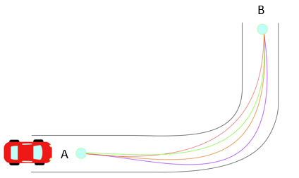

Figure Different Trajectories in a Given Path from Point A to Point B

* + 1. Traditional Methods for Trajectory Generation

In autonomous vehicles, many techniques have been used to generate trajectories traversing curves that satisfy a set of given constraints [9] [10] [11]. These techniques are mostly based from Calculus of Variations in which one or many parameters are chosen to be optimized. This can be either total length, velocity, acceleration, or a combination of them. These parameters are related through a functional (function of functions). Thus, most trajectory generation methods are used to optimize parameters within a functional. The most common parameter to minimize is the magnitude of the jerk (derivative of acceleration) which is related to driving comfort. This is shown by the functional:

Where:

x = Horizontal Position of Vehicle (m)

y = Vertical Position of Vehicle (m)

t = Time (sec)

The resulting solutions often result in fifth degree polynomials in the form:

Where the coefficients and can be found from boundary conditions existing in the starting and ending points. A complete formulation of these problem for the example of jerk minimization is offered on section 4.2.1.1. Solving these optimization problems yields an equation known as Euler-Lagrange which often leads to fifth degree polynomials for with differential constraints [12] [13]. These methods often need non-holonomic constraints which are defined as constraints on higher order derivatives of the positions (i.e. velocity and acceleration).

Other techniques involve generating clothoids (or known as Euler spirals, or spiral curves) which are usually used in road design. This curves are created by doing a parametric plot of two different Fresnel Integrals. By definition, Fresnel Integrals are trigonometric integrals that cannot be solved analytically. Often, series approximations are used for solving for Fresnel Integrals such as:

Because of this type of non-closed form solutions, numerical methods have to be used for the calculation of clothoids. This pose a problem because time of computation increases considerably compared to the fifth degree polynomials.

* + - 1. Euler-Lagrange General Formulation

*Find a function such that the functional is stationary (is minimized or maximized). Along with boundary conditions of the form and.*

Assuming all functions have a continuous second derivative, it is possible to state: Let be a solution that makes stationary and satisfies boundary conditions. With this, it is possible to introduce a new variable and let it have zero boundary conditions. Having this new variable, it is possible to re-write* the problem in terms of a new arbitrary variable which is denoted as the variation of:

Where:

= Variation of Variable which can be a family of curves based on different boundary conditions

= A function that makes stationary, for example, a solution to the problem that minimizes functional in the case of jerk

= Small variation coefficient

Through introduction of Equation (1), it is possible to change the problem from solving for to solving for. Thus, turning the problem in the following form:

Find a function (or family of functions) which makes the new functional stationary.

Given that Equation (1) makes dependent on, the integral of will provide a functional that only depends on. For this reason, it is possible to make an optimization problem with simply the derivative of the functional with respect to:

In optimization problems, it is necessary to evaluate the function (or functional) at an extrema point. For this situation, can be evaluated at zero, which will provide an extrema as follows:

Provided the assumption of is a solution that makes is stationary. By setting to zero, the functional has been optimized.

To evaluate this optimization problem, the definition of is used which gives an integral equation to solve:

The previous integral-differential equation is solved which provides the following function:

This final equation is a product in between an arbitrary parameter and a functional. Therefore, for the previous equation to be true for any arbitrary. The following has to be true:

Therefore: If makes stationary, then must satisfy the previous equation know as Euler-Lagrange Equation. The details of the steps to obtain the Euler-Lagrange Equation are provided in the Appendix, along with a validation of how the variation satisfies the same boundary conditions as, which allows to use the variation as a valid solution approach.

* 1. Trajectory Criteria

From literature review, the following criteria was selected to generate a path that solves the problem statement. The path generated needs to be:

* Able provide a smooth ride for the driver
  + In example, makes the derivative of acceleration below a threshold level. However, does not necessarily have to be minimized.
  + From ASSHTO guidelines, parameters for a smooth ride:
    - Lateral Acceleration: 0.4 to 1.3 m/s2
    - Jerk Values: 0.3-0.9 m/s3
* Able to transmit the least amount of data as possible
  + In example, data transmitted has to have a size limit for optimizing speed of transmission.
* Considered for compatibility with different vehicles.
  + In example, the dynamics experienced by a vehicle undergoing this path, needs to be appropriate for different vehicle sizes and types.
  + From AASHTO guidelines, overall vehicle lengths:
    - Passenger Car: 19.0 feet
    - Single Truck: 30-39.5 feet
    - Buses: 40.5-60 feet
    - Combination Trucks: 45.5-114 feet
    - Recreational Vehicles: 30-53 feet

By developing this method, the outcome is expected to create a vehicle ride that is independent of:

* Road type
  + This provides independence on whether the road has pavement or road markings.
* Infrastructure signs
  + Which gives a backup to image recognition software and machine learning/neural network techniques.
* Weather conditions
  + This provides a backup to camera sensors or lidar sensor which tend to fail on detection under different weather adversities.

Similarly, it is desired that the method is general enough to be compatible with other vehicles for future applications. The techniques cited before [9-16] are able to satisfy some of the criteria stated above. However, to reduce the amount of data transmitted as possible, a set of additional parameters needed to be considered. These were used to compare methods of path generation and develop a proposed solution. These parameters include:

* Computation time offline and online
* Size of transmitted data online
* Length of road section needed
* Dynamic constraints such as maximum acceleration and velocity
* Geometric constraints such as curvature and road geometry

From comparing techniques, it was noted how most boundary value problems such as [12] [13] offer solutions of analytical higher order equations, while others contain non-closed forms [10]. Consequently, high computation costs are needed to calculate trajectories during onboard operations. Solutions compared include coordinate and curvature polynomials of high order. These type of polynomial solutions introduce rounding and truncation errors that typically occur in machine operations [17] [18]. In autonomous vehicle operations, both accuracy and speed are essential for optimum performance. As accuracy of polynomial approximations increase by extending the operations of polynomial coefficients, its speed of transmission decreases. Decreasing the amount of coefficients provide non-compliant solutions, and the sensitivity of the coefficients is affected as well. This makes accuracy and speed of transmission an inverse relationship which should not be allowed for this V2I technology.

In this project, it was determined that size of data should be minimized during transmission per length segment. Through this analysis, it was noted that conventional path generation techniques onboard vehicles do not offer a reliable solution for infrastructure data transmission.

* + 1. Problem Solution

An approach was selected for a discrete solution based on offline road geometry generation. Focused on its minimum data transmission.

* 1. Mathematical Formulation

A set of unit vectors known as Normal-Tangential (N-T) Coordinates is used for the formulation of this path. N-T coordinates have been used extensively in works that define curvilinear motion of particles in space [19]. For this project, a 2D Euclidean space is selected in which N-T coordinates will be used to represent the motion of vehicle’s center of mass traversing a curve as shown in Figure 2.

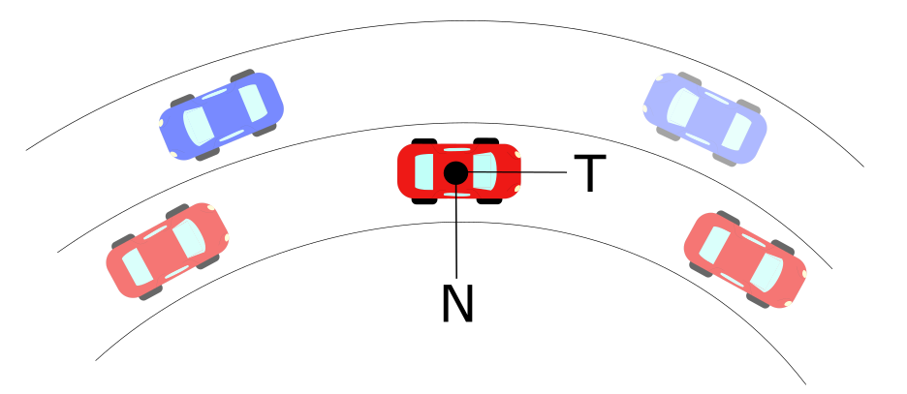

Figure Normal-Tangential Coordinates Along a Curve

As the vehicle goes through the curve, it is limited to constraints provided by road geometry and friction limits on the vehicle tires [20] [21]. These limits are related to the acceleration a vehicle goes under circular motion, which is denoted as:

(1)

Where:

a = Total Acceleration of Vehicle (m/s2)

v = Tangential Velocity of Vehicle (m/s)

= Curvature at an Instantaneous Point (m-1)

N =Normal Unit Vector

T= Tangential Unit Vector

Curvature can be defined analytically, physically and geometrically. It measures how fast the tangential unit vector T changes with respect to an instantaneous point in the curve. The inverse of curvature is known as radius of curvature ρ which indicates the radius of circumscribed circle at a point in a curve. By definition of N-T coordinates, a vector perpendicular to the curvature direction will provide a velocity tangent vector approximation. This velocity vector provides a heading angle to the desired trajectory that is needed to follow a road path.

This curvature can be expressed in a vector form that has a direction in the Normal Unit Vector shown in Figure 2. Derivations for defining curvature have been extensively developed in other works [19] [20]. The derivation of interest is explained in detail below.

*Discrete Curvature Formulation*

Let a scalene triangle with corners A, B, C have a circumscribed circle of radius R in Euclidean 2D space as shown in Figure 3.

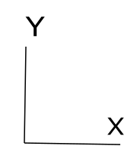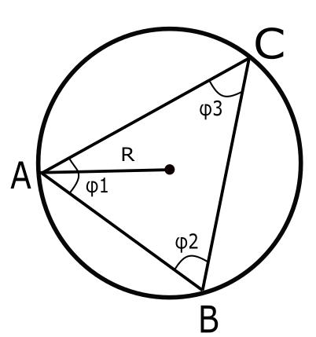

Figure Circumscribed Circle in Scalene Triangle

If we let a vector D be the cross product in between the vectors AB and AC, the direction will be pointing out normal to the plane defined by the intersection of AB and AC. By definition of the magnitude for cross product:

(2)

Let a vector E be the cross product of D with the vector AB, defining this new vector in the direction of as shown in Figure 4. Let the magnitude of vector E be defined as:

(3)

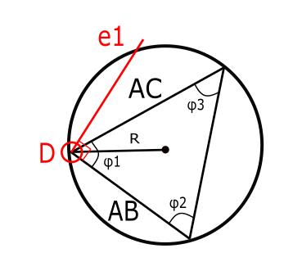

Figure Circumscribed Circle with Unit Vector

Similarly, let a vector F be the cross product of D with the vector AC, defining this new vector in the direction of as shown in Figure 5. Let the magnitude of vector E be defined as:

(4)

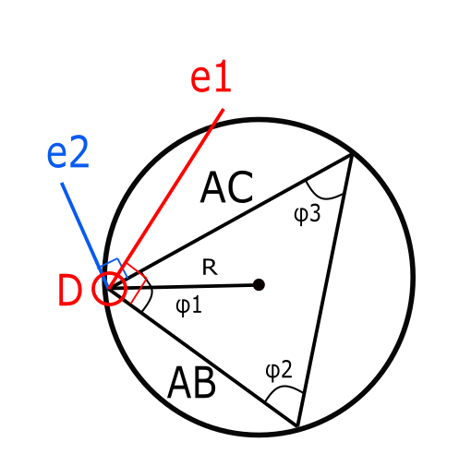

Figure Circumscribed Circle with Unit Vectors and

The unit vectors of and are defined by the following:

(5)

(6)

By definition, the midsection of any triangle’s side intersects with each other at a point P as shown in Figure. These intersecting lines denote two triangles with the same angle in between the unit vectors and their corresponding midsections as shown in Figure 6 below.

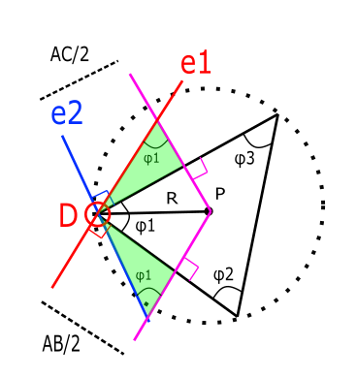

Figure Triangles Formed through Intersections of Unit Vectors

From these triangles, the components of vector DP along unit vectors and can be obtained:

(7)

(8)

From our previous definition of the vector D, it is possible to simplify further:

(9)

(10)

With these components, it is possible to obtain the full vector as the sum of the components:

(11)

(12)

Using previous definitions of E and F:

(13)

Using previous definition of D, it is possible to obtain the radius of the prescribed circle in terms of only the difference in between points A, B and C.

(14)

Using the previous definition, it is possible to apply the formulation of R to differentially small arc segments as it is shown in Figure 7.

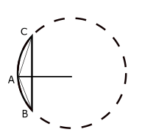

Figure Scalene Triangle in Arc-Segment

By definition, the radius of this circumscribed circle is called radius of curvature, and its inverse is known as curvature denoted as:

(15)

Through this definition, it is possible to extend the application of this discrete radius of curvature and applying it to long-discrete arc segments as shown in the Figure 8 below.

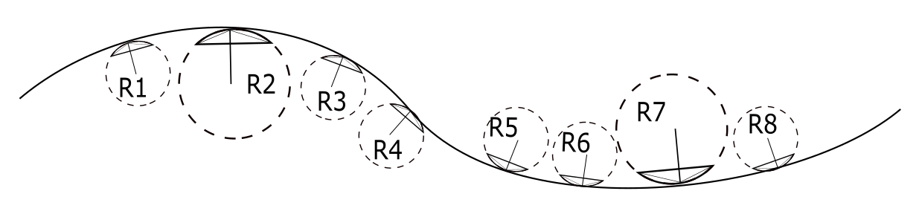

Figure Road Section with Discrete Sections

Based on this method, it is possible to obtain curvature vectors at discrete sections of any given road. With these vectors the heading angle can be calculated through two different approaches. The first method comes from numerical integration and the second one from an orthogonal phase shift.

* + 1. Heading Angle Integration Formulation

The arc-length s of a curve is defined as the length traveled by a certain amount of degrees along a constant radius r. If s is sufficiently small, a triangle can be formed in between these three parameters, which are related through geometry:

Defining r as the radius of curvature at the specific arc-length and letting.

By the previous assumption of small angles:

Which leads to

(1)

Let the Curvature be denoted as

Substituting this definition into equation (1)

Assuming a differential section for and. Rearranging for:

By separation of variables and integration

Which concludes that the angle of orientation as a function of arc-length s can be found through numerical integration of the curvature as:

To obtain the curvature, let a scalene triangle with corners A, B, C have a circumscribed circle of radius r.

* + 1. Heading Angle Orthogonal Shift

From Figure 2, it is possible to notice that N-T coordinates offer collinearity in between the normal unit tangent vector and the curvature vector for any given curved road. Given this, it is possible to obtain a base heading angle that involves an orthogonal shift to the curvature vector.

This shifted curvature vector is collinear with the heading angle as along as the vehicle follows the same curvature that the physical road has. Typical highway roads are designed based on AASHTO guidelines to provide a natural, easy-to-follow path for drivers, such that the lateral force increases and decreases gradually as the vehicle enters and leaves a circular curve [24]. This leads to an approach of curvature generation based on AASHTO road geometry to obtain heading angles. To develop this, the aforementioned definition of radius of curvature is used to obtain both its magnitude and direction [25]. The radius of curvature is computed from discrete points that represent coordinates of a road.

* 1. Road Slicing

The road slicing method comes from obtaining data points of a road. This data can come in the form of different sources such as digital maps, design guidelines, lidar scans or GPS measurements. From this data, it is possible to apply the mathematical formulae from sections 4.4.1 and 4.4.1 to obtain a road segment along with its heading angle direction. In order to explore the effectives of road slicing, different methods to coordinates were used. The first method involved a base model of the road based on AASHTO design guidelines. The second method involved using Google Earth coordinates. The third method involved using GPS coordinates

* + 1. AASHTO Base Model

This model consisted on strictly using AASHTO guidelines to design an ideal highway road for a vehicle traversing at constant 60 mph with the highest degree of elevation. The curve consisted of 5 different sections that can be classified as: straight section, entrance transition, constant radius curve, exit transition and straight section. Applying the discrete geometric approach to this curve, curvature vectors were plotted with respect to the road segments as shown in Figure 9. The curvature vectors were plotted with respect to road segments to obtain a base curvature profile as shown in Figure 10.



Figure AASHTO Base Model: Road with Curvature Vectors



Figure AASHTO Base Model: Curvature κ vs. Cumulative Curve Length

With the curvature profile established, two different approaches were used to confirm the heading angle approximation. The first method involved obtaining the heading angle from the Discrete Curvature Formulation and add an orthogonal phase shift. The second method involved using the Heading Angle Integration Formulation which has been explored in different studies [**Error! Reference source not found.**]. The results of both methods are shown in Figure 11 and Figure 12. Results on heading angles with respect to road segments are shown in Figure 13. These resulting angles were used as input data on a controller developed in Chapter 6.



Figure AASHTO Base Model: Orthogonal Phase Shift Approach



Figure AASHTO Base Model: Numerical Integration Approach



Figure AASHTO Base Model: Road with Velocity Vectors

* + 1. Google Earth Model

This model is based off a selection of points in Google Earth that represent a highway road with design speed of 60 mph. The points were picked as close as possible to resemble the road centerline of the highway. The road profile and resulting vectors from applying the aforementioned discrete geometry approach are shown in Figure 14. It is noticeable how the vector directions choose arbitrary tangent directions when the curve approaches a straight line section. The curvature magnitude with respect to length was also plotted in Figure 15 and it was observed that magnitude deviations increased considerably compared to the ideal AASHTO model.



Figure Google Earth Model: Road with Curvature Vectors



Figure Google Earth Model: Curvature κ vs. Cumulative Curve Length

The method was not efficient in calculating curvature magnitudes, but the direction of the heading angle obtained from the orthogonal phase shift still provided comparable results to those found by calculating with AASHTO as shown in Figure 16. Similarly, the resulting velocity vectors to guide the vehicle provide a suitable heading direction as shown in Figure 17. These resulting angles were used as input data on a controller developed in Chapter 6 to study the efficiency of navigating with this input information.



Figure Google Earth Model: Orthogonal Phase Shift Approach



Figure Google Earth Model: Road with Velocity Vectors

1. SECOND STEP: VEHICLE GUIDANCE/WARNING
   1. Problem Statement

In order to determine if the local path generation method is viable, a vehicle control structure needs to be developed that is based on the local path data. The control system needs to accurately keep the vehicle on the road, by means of driver alters or direct vehicle control.

* 1. Introduction

Driver assistance and autonomous vehicle control technologies are a new and developing in the automotive industry. Advanced driver assistance systems (ADAS) are systems that are available in most new vehicles on the market however their range of capabilities depends on the specific vehicle model. The goal of ADAS is to use a suite of sensors in and around the vehicle to monitor the environment to detect if there is anything that will endanger the vehicle occupants and alert the driver to take corrective action or by taking direct control of the vehicle. These hazards can include other vehicles, pedestrians, wildlife, and lane boundaries. Autonomous vehicle (AV) technology is a level above ADAS as it seeks to be in control of the vehicle at all times and uses additional sensors in comparison. AVs are still in the prototype and development phase and are operated under the guidance of a team of experts and are constantly monitored and never allowed to be fully self-sufficient as is the end goal.

As previously mentioned both of these systems are reliant on a suite of external sensors. The sensors interpret the environment and the onboard computer processes the information to determine what actions are necessary. These sensors are accurate in controlled environments, however, on the roadway they are effected by a variety of variables. This can be related to inclement weather that obstruct the sensors’ view, other electrical signals in the environment, poor roadway labeling, and complex road geometry like sharp curves and hills [31-36]. This method of road data collection creates a problem for controlling the vehicle correctly at all times and in all scenarios as vehicle sensors can obstructed or just from interpreting the data incorrectly.

* 1. Driver Assistance Literature Review

ADAS has three different tiers of operation. The first is a no action tier when the vehicle is on course and no foreign objects are encroaching on the vehicle. The second tier is driver warning system that is initiated when undesirable behavior is detected. The third tier is vehicle override control which occurs when the driver is not responding to alerts. There are many different modules of ADAS for object avoidance, however, the only commercially available modules that are dedicated to keeping the vehicle on the road are the lane departure warning (LDW) and the lane keeping assist (LKA) modules. These two modules are effectively identical except that LKA has the ability to steer the vehicle back into the lane where as LDW is just a warning system.

In current LDW systems the driver is alerted based on certain thresholds defined by the vehicle. In order for these thresholds to be calculated information from the road must be extracted and modeled. This is the main focus of research in the field of LDW as it is the most complex part of the system. If the road model is incorrect then the warning system will have no chance of working properly.

There are a plethora of LDW systems that have been researched. Most use forward facing cameras to gather information about the lane edge markings. The obvious implementation of a camera is to optically see that part of the vehicle is over the lane edge in much the same manner that humans do. The other use of optics is to obtain data regarding the lane edges. This lane data is used to develop a mathematical representation lane boundaries. Near fields can be modeled as linear functions as the road doesn’t change very quickly over a very short distance therefor linear functions are an accurate representation for those short segments. More complex functions are used to model the extended road lane edges where linear functions no longer are accurate enough. One implementation of this is combines a linear for near field prediction and a parabolic curve for far field estimation [37, 38]. These lane approximations are used to both locate the vehicle within the lane and also determine what dynamic control is expected to navigate the upcoming road. Another, more simplistic, use of lane edge data extraction is to calculate the relative orientation of the left and right lane edge relative to the camera perspective to approximate the vehicle’s location within the lane and estimate a time to lane change [38-40].

LDW systems can also be based on a measured vehicle and road position. In addition to using sensors to view the road edges the current position of the vehicle is compared to a high level map to determine whether or not the vehicle is off the road. Using GPS to detect lane departures using a combination of accurate mapping data and a vehicle GPS unit is a commonly researched technique. [41-45]. There are many small differences in the techniques used to increase GPS accuracy and localize the vehicle within the lane to determine whether the vehicle has left or is close to leaving the road.

* 1. Driver Warning System Development

The goal of this ADAS is the same as any other ADAS, to alert the driver or take over control of the vehicle if the vehicle is conducting unsafe behavior. The development of this system is based off of the road data was transmitted to the vehicle for the next section of road, including local x and y data, road curvature and road heading angle. A few assumptions where made in this development and simulation. The first is that the road data that the vehicle receives is one hundred percent accurate compared to the actual road geometry. Another assumption is that there are no foreign hazards in the path of the vehicle, i.e. pedestrians, other vehicles, etc. We also assume that the road surface is ideal and there are no bumps or other disturbances that could set the vehicle off course. It is assumed that the vehicle knows its position relative to the desired path with absolute certainty as our initial focus is to develop threshold based on the outcomes rather than the reliability of position. In the development of thresholds related to vehicle friction capacity the aerodynamics effects on down force or lift are neglected and it is assumed that the normal force of the vehicle is only related to vehicle weight and ground slope, however the needed of aerodynamically based speed limit is discussed.

* + 1. Requirements

At the basis of this ADAS system is a myriad of thresholds that determine whether or not the occupant is in danger. This is based on the information that the vehicle has with regard to its current environment. Now with a regulated and verified road geometry data set transmitted to the vehicle, the same process can be accomplished more accurately. Therefore we will discuss the thresholds that we determined provided effective means of keeping the vehicle on course.

There are some criteria that we want our system to be capable of accomplishing. The ADAS system needs to be able monitor when the vehicle about to depart its desired lane and notify the driver of the error or take its own corrective action. It also needs to have additional parameters that will help identify vehicle instabilities and other issues that will cause the vehicle to lose control or exit its lane. In this way the system has the ability to have a predictive nature to its alert system rather than just alerting when something has already gone wrong.

* + 1. Vehicle instabilities
       1. Excessive Speed

One threshold that is important to determine is if the vehicle is carrying too much speed into a particular curve. Speed is an important factor in regards to the turn radius of a vehicle. As curvature of the road increases, as long as the vehicle maintains the same speed, the lateral acceleration of the vehicle increases with the following relationship for a level surface:

Now this becomes a problem because this lateral acceleration creates a lateral force in the vehicle. This force is resisted by the lateral friction force between the tires and the road surface. However, tires have a maximum friction limit that they can handle. Once the limit is surpassed the vehicle will slide out of control of the driver. The National Traffic Safety Administration (NHTSA) has a formula that prescribes a maximum vehicle speed threshold for a given road configuration.

This formula compensates for the fact that vehicle roll angle increases on elevated curves allowing for additional speed capacity. Additionally it accounts for the side friction factor that is prescribed by AASHTO which applies a factor of safety to the maximum amount of lateral friction force needed. However, this is a safe speed that works under all road conditions. If this were to be set as the speed threshold for ADAS engagement it would be constantly violated by drivers and be more of a nuisance than it would be helpful.

Therefore a threshold needs to be developed that allows for elevated speeds so that the driver is only notified when they will not be able to safely transverse the upcoming curve. Although it is not desired, the driver essentially should have the freedom to travel in excess of the speed limit as long as it doesn’t compromise the stability of the vehicle. If the vehicle system limits this ability, the driver will choose to just disable or turn off the system.

A general maximum level speed limit above the legal limit can serve as the base level of warning. This is especially useful when the vehicle is just traveling in a straight line and does not require any dynamic steering input. The vehicle environment will alter the degree to which the driver can exceed the speed limit. In urban setting the threshold should be kept closer to the legal speed limit as the safety of pedestrians is more of a significant concern. If the vehicle is travelling on the interstate the risk of colliding with a non-vehicle object is much lower allowing the threshold to increase with respect to the prescribed speed limit. Government agencies should be consulted as to this maximum level above the speed limit especially as it pertains to the safety of non-vehicle personnel to help determine what this speed limit allowance should be.

An overall speed limit should also be prescribed. Elevated speeds can result in a lift force imposed on the vehicle from the pressure differential between the top and bottom surfaces of the vehicle. This negatively affects the control capacity of the vehicle as normal force transmitted through tires is reduced. Vehicle with higher center of gravities and high ground clearance are particularly susceptible to this as it allows more air flow under the vehicle. It will be up to the manufacturers to determine what this top speed limit should be as it is dependent on the specific vehicle model.

Another threshold can should be developed based on the verified data regarding the road ahead by predicting the vehicles ability to negotiate the upcoming roadway. A vehicles ability to successfully negotiate a specified curve is dependent on the vehicle’s speed and steering system characteristics. In cornering there are three types of vehicle behavior: neutral steer, understeer and oversteer. For a constant-radius turn if vehicle speed is increased the steering input must remain the same, increased or decreased for the three vehicle behaviors respectively. Most vehicles on the roadway follow an understeer behavior, thus it will be the configuration of interest. When cornering at high speeds there is a point at which no matter how much more the driver steers, the vehicle cannot turn anymore. This is a result of the friction between the tires to ground reaching full capacity. Therefore there is no more available friction force available to counteract the increased lateral acceleration. This is a point that is not desired to be reached as the vehicle will not be able to be stably controlled.

In designing road for specific speeds according to AASHTO guidelines they use a .15 friction coefficient as a safe metric for allowable side friction [24]. This metric is equivalent to the amount allowable lateral g-force experienced by the vehicle. It is assumed that for an average vehicle (no significant tire wear) and for an average road surface that the maximum total available friction coefficient is around one. The typical friction experienced by the vehicle need to be kept much lower so that it has left over capacity should it need to make any dynamic maneuvers. A very small portion of this limit goes to the longitudinal movement of the vehicle as the vehicle accelerates forward and due to wheel slip that occurs a constant speeds as well as when accelerating. A change of allowable in lateral acceleration could be a metric that could be altered to increase the allowable travel speed. However lateral wheel slip occurs before friction capacity is reached.

Therefore a more accurate measure by which to predict the vehicle’s ability to traverse a curve is to use the understeer modified Ackerman equation [52].

This accounts for lateral wheel slip in the vehicle. This formula can be used to predict whether the vehicle has the physical capacity to traverse the upcoming curve given it current speed and steering limits. The physical steering limits of then should be compared to the estimated wheel angle as it should not strain the physical limits. For low speeds the percentage of allowable angular wheel steer is greater than is allowable for higher speeds as the minimum safer turn radius increases. An inversely proportional relationship between speed and percent difference between steering angle based on the prescribed road speed can be applied so that the higher the speed, the less leeway the driver will have before being alerted to slow down.

* + - 1. Roll Over

In addition to the maximum friction limit, roll over parameters of vehicles impact the vehicle speed limit heading into a curve. Vehicle roll instability occurs when the normal force corresponding to one side of the vehicle transmitted to the tires is equal to zero. This will result in the vehicle rolling over onto the side of the vehicle or even further. This also results and loss of vehicle control as one side the vehicle no longer has any potential for friction development.

Roll stability is primarily dependent on the lateral acceleration of the vehicle as it impacts vehicle weight distribution as the vehicle corners. A vehicle propensity for roll over is dependent on the track width and center of gravity height as they effect the magnitude of the moment that force resulting from lateral acceleration. The wider the track width and the lower the center of gravity the more lateral acceleration is needed to overturn the vehicle. A critical speed is defined for roll over instability at which there no normal force on one side of the vehicle:

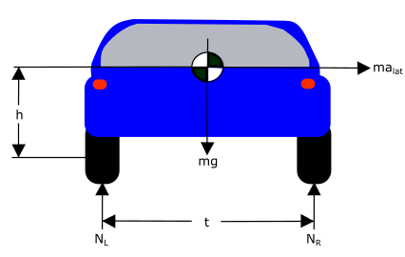

Figure Track Width Vehicle Model

* h- vehicle c.g. height
* g- gravity
* m- vehicle mass
* alat- lateral acceleration
* t- track width
* NL- normal force left
* NR- normal force right
* V_crit – critical roll speed

*for a stationary vehicle

This formulation does not account road slope which would allow for a higher critical velocity for roll over. However, by excluding road slope this metric is given a factor of safety. Therefore as a recommended vehicle limit, the vehicle critical road speed for a given curve should be used to set a speed limit warning when approaching a curve.

* + 1. Departure Thresholds
       1. Orientation Error

A measure that is helpful in predicting potential road departures is orientation error. Orientation error is difference between the ideal heading angle of the roadway and the current heading angle of the vehicle as described in Figure 24.

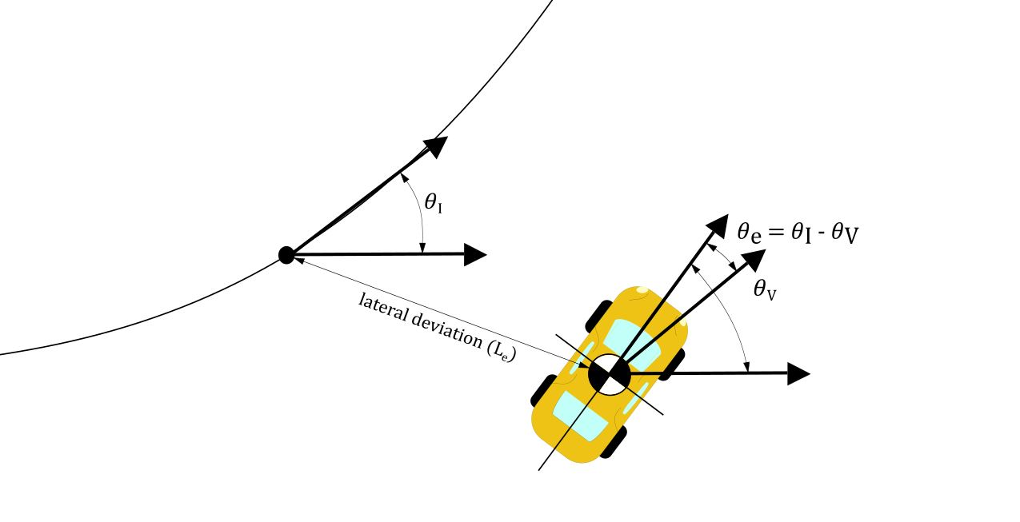

Figure Heading Error and Lateral Deviation

Using the realistic AASHTO roadway data, heading angle error was multiplied by the current vehicle speed of 88 ft/s and error was calculated against lateral deviation rate. It can be seen in FIGURE ### that for small values of heading angle error that it is equivalent to the lateral departure rate from the path for the given vehicle speed. Therefore can be used as a signifier for predicting if the vehicle is trending out of its lane.

Figure Departure Rate According to Heading Angle Error

Now since human driving behavior is imperfects as people do not perfectly mimic the centerline trajectory of the road. Instead the typical driving behavior is to gradually oscillate around the centerline. Therefore some heading angle error is expected, and a threshold needs to be determined that dictates when the heading angle error is abnormal.

Now using a singular departure threshold may not always be applicable. Depending on the current position of the vehicle on the road and the width of the road the driver may need to be warned sooner. Departure rate can be used to calculate a time to road departure and determine when the vehicle needs to be altered. In order to determine what time to road departure is appropriate, real driving tests need to be conducted in order to evaluate the typical characteristics in regards to departure rate for an attentive driver and an inattentive driver. A good starting point is to alert the driver if the system determines that there is one second to road departure.

* + - 1. Rate of change of heading angle

When using heading angle error as a road departure characteristic the rate at which it is changing is a useful metric to separate normal driving characteristics and a departure. Typical driving behavior can be characterized by a slow oscillation around the lane centerline of the vehicle. Therefore under normal driving behaviors the rate of change in heading angle will also change as well and not trend in any particular direction. In the case of a road the departure the heading angle error rate will be a relatively constant value in the case of a straight road, and a constantly increasing measurement in the case of a curved roadway. So the rate of change in heading angle can be used to filter out false positives. A time lapse of constant direction, positive or negative, for a predetermine time threshold can be set to alert the driver before leaving the roadway, however this is complicated by current vehicle position and road geometry. It could, however be used in a secondary check to the current heading angle error and providing a time to lane change through curve fitting the recorded rate for the times steps since the last sign change. Once the function is approximated it would again warn the driver if a departure is predicted in less than one second.

* + - 1. Change in acceleration

Another measurement that can also help predict a roadway departure is the change in lateral vehicle acceleration over time. The reason that this is useful is that road curve transitions are traditionally built off of a desired change in later acceleration as it is a measure of ride comfort and safety. The equation as presented in AASHTO for calculating the necessary transition length is as follows:

In designing spiral transitions the maximum increase in lateral acceleration usually ranges between 1 and 3. It is another metric that can be used to determine whether or not the vehicle is following the desired path according to design standards. When components of the change in lateral acceleration is integrated over time we can predict the future heading angle of the vehicle and calculate the error to the desired orientation error.

As previously discussed heading angle error is proportional to departure rate. By using lateral acceleration we could predict what the future rate of road departure could be based on current dynamics.

* + - 1. Lateral Deviation

Vehicle deviation from the desired trajectory is an important characteristic as it is the ultimate determination of vehicle safety with regards to staying on target. In the scenario of slow and gradual departure, it is the only subsystem that will detect the issue because the short term vehicle behave is stable.

In order to determine the lateral deviation from the path the vehicle computer uses the XY data that it received from the infrastructure network in the beginning of the route and compares it to its current XY position in the local framework. After calculating the relative error between the desired road path and vehicle position, the component of the error measurement that is normal to the road path is used to determine the lateral error.

Current lateral deviation is a vital part of the system as other departure metrics are dependent on the current lateral deviation to predict the time road departure. It is also the used as the last line of defense so to speak, meaning that if the vehicle behaves in such a way the no other thresholds are triggered, if the vehicle is on or over the lane boundary, the lateral deviation threshold will trigger an alert. This threshold should be set to be triggered when the vehicle has deviated enough to be on the lane boundary.

* 1. Safe Stop Scenarios

The purpose of most of the developed thresholds, excessive speed, orientation error, change in lateral acceleration, determine whether or not the driver should be warned of unsafe behavior and to take corrective action. No control of the vehicle is taken over by the computer system as there is only potential for a safety hazard.

In the case of excessive lateral deviation, road departure has already occurred. If at this point no drive input has been detected the vehicle computer must take over control to bring the vehicle to a safe stop. A safe stop is maneuver in which the vehicle is brought to a controlled stop and the vehicle is also steered to the side of the road way so that it is out of the way of traffic when it comes to a stop. The point at which this takes place is a complex question as it is dependent on the particular vehicle as well as the road configuration. These factors need to be accounted for in the development of a safe stop protocol.

Different road configurations affect when the safe stop occurs. In the case of large road shoulder, with no nearby roadside hazards, the vehicle could be allowed to venture over the road edge and onto the shoulder before the computer takes over control. However the opposite scenario is on narrow mountain roads that have no shoulder the vehicle has a smaller error window before a safe stop can be invoked.

In additional to the roadside configuration the lane configuration also plays an important role. One of the outcomes of the safe stop is bringing the vehicle to the side of the road, however if the vehicle is traveling on a road with multiple lanes the vehicle cannot automatically deviate to the side of the road to stop if it is in an interior lane. In this instance the vehicle would slow down to a creep pace instead of a full stop while until it determines that it is safe to changes lane and make its way to the side of the road. This process would require the use of either external proximity sensors or vehicle to vehicle (V2V) communication to determine if there are any vehicles in the relative proximity before making any maneuvers.

* 1. Emergency Stop Evaluation

Simulations were conducted to investigate road departure characteristics. One of the worst case scenarios is for an inattentive driver on a curve. This simulation assumes that the driver is not responsive to departure alerts. This scenario is explored to determine at what point an ADAS needs to take over control, and what kind of control input is necessary to prevent the vehicle from running off of the road.

The first simulation does not apply ADAS control until the outside tires of the vehicle are on the shoulder of the road, a lateral deviation of 6ft or a 12 ft wide road. Once the vehicle reaches this point, full brake is applied with no steering input. It is assumed that the maximum deceleration rate is 1 G. The road that was used in this simulation was an AASHTO regulated curve designed for travel speeds of 60 mph. The road is a transition designed for the highest allowable change in lateral acceleration as the road transitions from a straight lane to a constant radius curve.

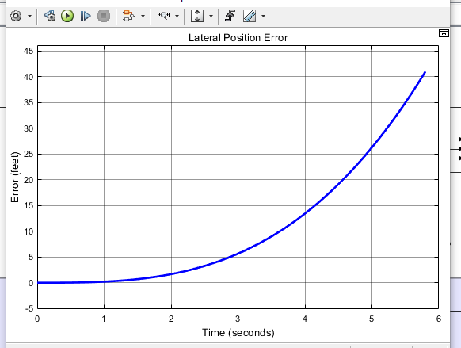

Figure Lateral Position over Time

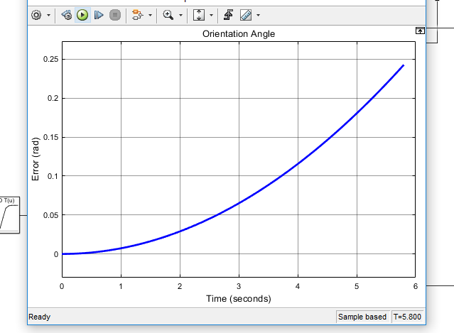

Figure Orientation Angle over Time

The vehicle starts in the middle of the lane and gradually drifts to the side of the road as no steering correction is made as it travels down the road. The vehicle position reaches the outer road boundary in approximately three seconds. It is interesting to note that the orientation angle at that point the error in orientation reaches a maximum value of 0.07 radians. Even though the orientation is small a road departure occurred over time because orientation error persisted. When the vehicle reaches the road edge the vehicle is slowed at a rate of 1 G. The emergency stop protocol was not evoked until this point to allow for as much lateral deviation as possible before braking. When the vehicle comes to a complete stop the lateral error is at its overall peak of 41 ft, 35 ft, at which point the vehicle has far exceeded

When braking from 60 mph the vehicle takes 2.8 seconds to stop. In order for the vehicle to be stopped without any leaving the roadway the brakes need to be applied before an inch of deviation occurs. Therefore a steering input commands also needs to be applied in an emergency stop protocol to stop the vehicle on or near the road. This will be discussed in further sections as the vehicle steering control is developed.

* 1. Threshold Summary

Discussed in this section where various metrics by which driver can alerted or the vehicle computer takes over control to remain on the roadway. The next step in this series to drive real vehicles with necessary sensors to capture the data necessary to determine which predicted thresholds would be the most effective in being the support structure of an ADAS.

* 1. Vehicle control literature review
     1. Control methods
        1. PID Control

One of the most common control methods used in industry is the Proportional Integral Derivative (PID) controller. PID controllers are a feedback controller, meaning that the output variable(s) of the system are fed back to the control which prompts a new control command into the system. The control structure is based on the error from the desired system output. The goal of a PID controller is to minimize that error. It accomplished this by taking the error, the derivative of error, and the integration of error with respect to time along with three individual gain constant and combining them to a system input as shown below

PID controller are modified to fit the specific system it controls by tuning the gain constants to achieve the desired output. The main performance factors that are consider when tuning a PID controller are rise time, overshoot, settling time, and steady-state error [Michigan website]. Rise time is the time required to reach the desired output value, when error is zero. Overshoot occurs when the system output reaches the desired value but the system doesn’t stop and overshoots the target. This occurs due to system inertia and the system doesn’t stop at the desired value. Settling time is the time it take for the system output to settle and remain with a certain percentage of the desired output, usually 10%. Finally steady state error the remaining error between the current output value and the desired value after the control process is finished.

The proportional constant, Kp, is adjusted to minimize rise time, the larger Kp the faster the output will reach the desired value. However the higher the value the will result in a magnified overshoot value. The primary objective of the integral constant, Ki, is to reduce steady state error. If a small error remains in the system, if it is integrated over time that small error with grow allowing the controller to compensate for it. The derivative constant, Kd, is to reduce overshooting and settling time. [47]. It affects the control output based on the derivative of error overtime so as the error approaches zero it reduces the amount of correction allowing for a smoother control.

PID is advantageous as it is simplistic meaning that it takes less computing time and power to achieve accurate results. This is important as intelligent vehicles need to be able to make decisions quickly. However this simplicity negatively affects the controller’s ability to control complex and nonlinear systems.

* + - 1. MPC Control

Another common control method used in intelligent vehicles is Model Predictive Control (MPC). MPC again works to achieve a desired outcome by minimizing the error between the desired behavior of the system and the actual outcome. This is done by first inputting the future trajectory path. The prediction horizon is a metric that dictates how far into the future the control extracts information in order to make decisions. The controller uses this future data to create a schedule of control steps for every time step to achieve the end result. This allows the controls step to be optimized to work together to efficiently control the system. The controller then applies the first control step to the system and then re-optimizes the control schedule taking into account the next additional times step [48]. An example of this is shown in Figure 28. MPC is particularly useful for vehicle control due to its ability to handle specified constraints. In the control parameters hard and soft constraints can be prescribed so that model will not violate key aspects of travel like road deviation, speed limit, and other vehicle limits.

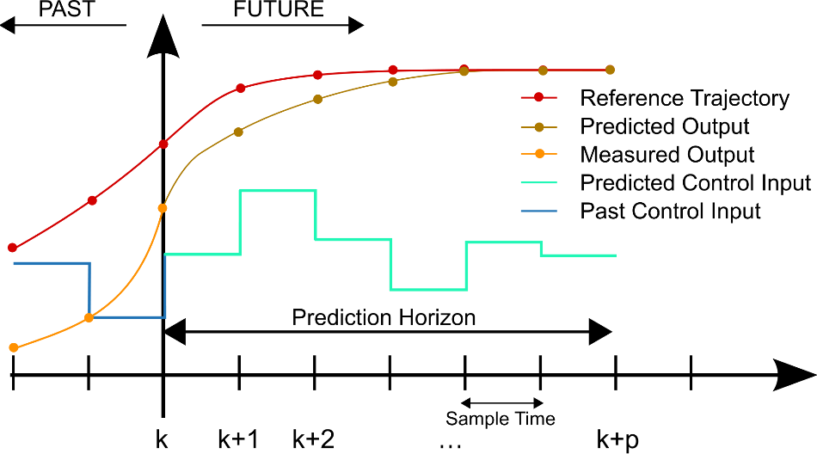

Figure Example of MPC Prediction and Control [49]

The major drawback of MPC control is that it is more computationally expensive as it re-optimizes the predicted control for every times step. This can be remedied by reducing the length of the prediction horizon, however, this negates the benefits the advantages of this aspect of the control method.

* + 1. Correction Methods
       1. Stanley method

One particular method to guide an autonomous vehicle is known as the Stanley method. This method applies a correction to regain the desired path based on heading error and cross track error, governed by the following equation:

The correction factor is then altered to by either increasing for a higher degree of correction or by decreasing for a smaller correction effect [50].

* + - 1. Pure Pursuit

Pure pursuit is a very common navigation method used in robotics. This method works by setting a path of data points. The current position of the vehicle is then used to calculate the radius of curvature of a path from the vehicle position and is used to estimate the wheel angle to achieve the target point. This is geometrically demonstrated in FIGURE ###. The desired steering angle is then calculated as follows [50]:

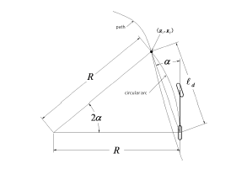

Figure Pure Pursuit Controller Geometry [50]

Pure pursuit is tuned by modifying look ahead distance. The look ahead distance determines how far ahead into the prescribed path the controller looks. This metric is very sensitive to the road geometry and needs to be tuned the specific nature the roadway. If the look ahead distance is too short the vehicle will tend to oscillate excessively due to small curve radii and if the look ahead distance is too long the vehicle will not accurately track with current vehicle path [51].

* 1. Vehicle control development

An effective AV system has two goals. The primary goal is to operate the vehicle so that the occupants are kept safe. The second goal is do so in such a manner so that the occupants can experience a comfortable ride.

* + 1. Road Model

The road data used in the ADAS development is based on the model of a standard road design based off of American Association of State Highway and Transportation Officials (ASHTO) guidelines to ensure a realistic road geometry. The particular road that was used is characterized by a gradual transition from a straight path to a constant radius curve followed by a transition back to a straight road. The particular road was designed based on travel at a 60 mph with a super-elevation of 12 and a side friction factor of 0.12 resulting in a minimum curve radius of 1,000 ft [24]. These values were chosen to simulate the smallest radius possible for the give speed so that the system would be evaluated at the limits that the vehicle would experience for a given speed.

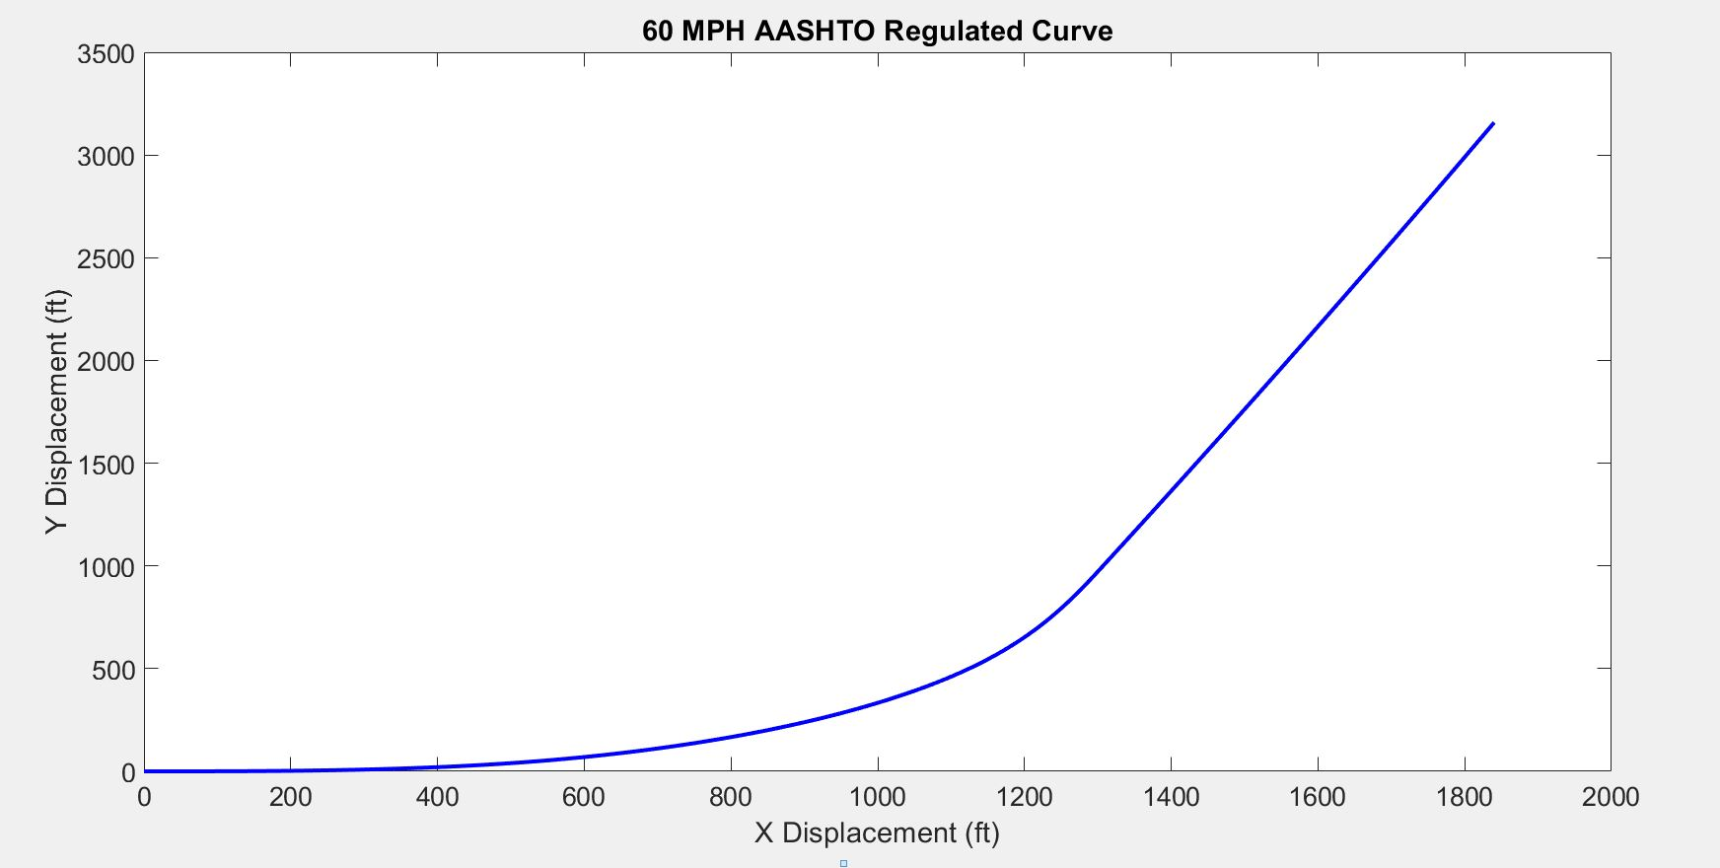

Figure Road Data XY Data

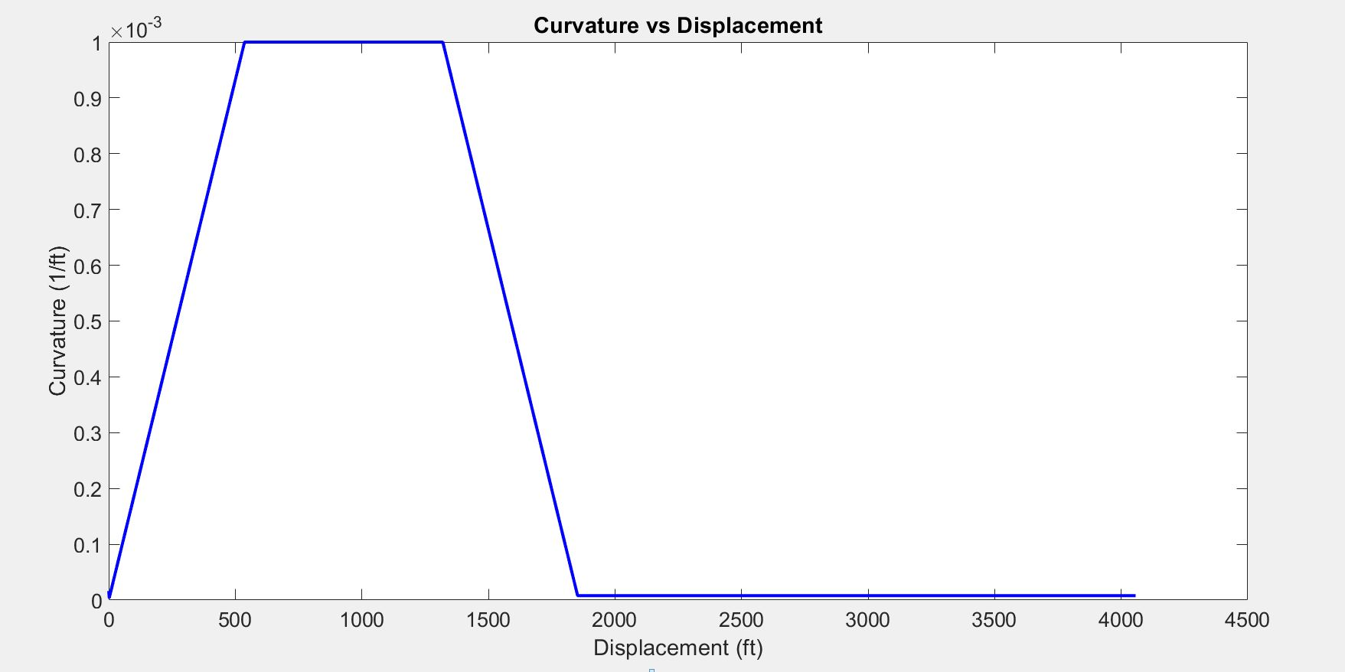

Figure Road Curvature Data

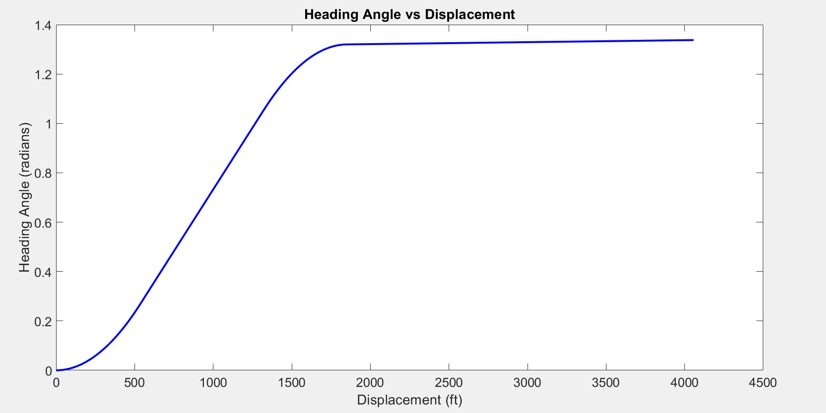

Figure Heading Angle Data

* + 1. Vehicle Model

The model used for developing a vehicle control system the bicycle vehicle model. The bicycle model is created by combining the front and rear axles of a vehicle together seen in FIGURE ###.

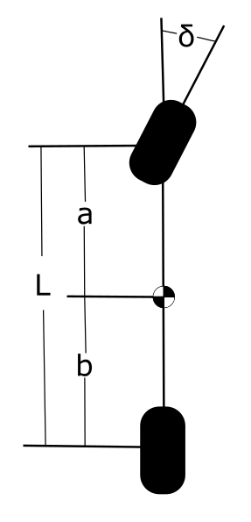

Figure Bicycle Model

The vehicle can be simplified in this manner because under stable conditions a vehicle’s cornering ability is dependent on wheel angle and wheel base. At elevated travel speeds this relationship is distorted due to lateral slip experienced between the wheels and the roadway and is related to lateral acceleration. This modification is dependent on specific vehicle geometry which is characterized by the understeer gradient [52]. These factors are combined to define a desired wheel angle in the understeer modified Ackerman equation:

The specific vehicle geometry that was used in the model was based off of the C-Class Hatchback 2012 template found in CarSim. This specific model has a wheelbase of 9.55 ft. The vehicle was simulated in CarSim and was found to have an average understeer gradient of 1.46 deg/g for the given road geometry previously described.

* + 1. Model Development

The control method used in the system was a PID controller. This method was chosen as it allows for a gradual ramp up and ramp down control, similar to how a human driver operates a vehicle. It also is effective in eliminating steady state error which plays a big factor when controlling over miles of road allowing for error to gradually build up if not corrected. Road data previously developed was used as the inputs into the system. The overall system utilizes three independent PID controllers that are each based the error from the wheel angle, future wheel angle and lateral deviation error respectively as seen in Figure 34.

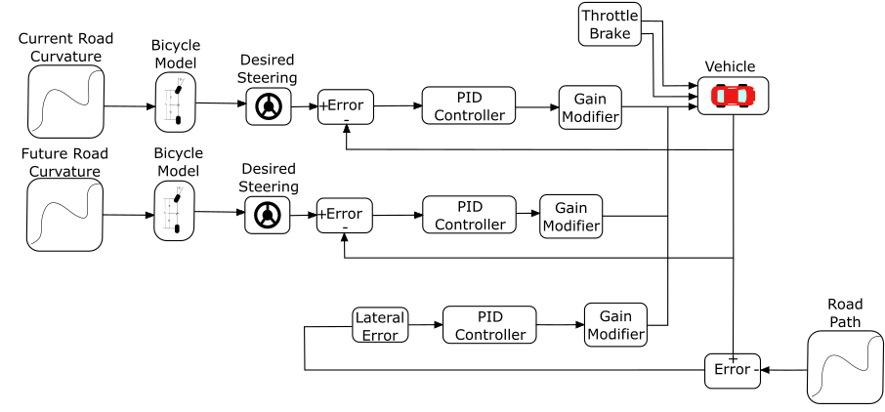

Figure Vehicle Control Schematic

The first PID controller was based on the desired wheel angle need to achieve a turn curvature equivalent to the current curvature of the road based on the modified Ackerman steer equation. In this system error is calculated between the current vehicle wheel angle and the current desired wheel angle. This error is input to the PID controller and an updated wheel angle is input into the vehicle system. The PID controller parameters, which can be seen in Table 1,where tuned in order to have a fast rise time as this is critical for staying on the road as delay in control is reverberated in road departure. This control was mainly dependent on the proportional gain parameter.

The second PID controller was based on the future desired wheel angle need to achieve a turn curvature of the road, again base on the modified Ackerman steer equation. The control of this parameter is identical to the previous PID controller and the same gain parameters are used as the same overall goal is identical as shown in Table 1.This additional controller helps the vehicle compensate for the fact that the road is constantly changing at a high rate of speed. Therefore by the time the previous controller has gone through the process of inputting the new desired wheel angle, adjusting the steering angle to the optimal angle the position with the corresponding steering adjustment is already long gone and it is already time for a new input. Adding in a future angle parameter allows the system to begin to progressively control the vehicle to start to steer in advance but not so much as to cause a large amount of lateral error.

The third input of control into the system is the minimization of lateral error to the path. This is a highly necessary part of staying on the desired path. Even if the heading angle and turn curvature has reach zero error the vehicle can still have residual error spatially related to the desired path. Minimizing lateral error keeps the vehicle on the road and prevents error from accumulating as the vehicle travels along the road.

The road reference used in the calculation of lateral error is the nearest road coordinate relative to the current position of the vehicle. The XY coordinates have been rotated according to the heading angle of the roadway, the lateral error becomes collinear with the curvature vector of the roadway and therefore is normal to the desired path. The magnitude of control associated with this error is far less than used in the previous PID controllers. The constants found to be the most effective and stable for the lateral error controller can be seen in Table 1.

The output of each of the controllers are where individually weighted to achieve the desired output. In this simulation it was assumed that the bicycle model was an accurate representation of the necessary steering input in order to stay in on the road. Therefore the current steering angle serves as the primary mode of control in the system and mainly dictates the steering wheel angle into the vehicle system.

The next tier of control impact is the future desired wheel angle. This is given second priority based on the previous reasoning for the current wheel angle. However the weight associated with this controller is far less in magnitude because if too much magnitude is used the vehicle would potentially rely too much on the on the future road and leave the current roadway as a result.

The final controller, based on the lateral error has the smallest impact on the system based on its weight relative to the others. The theory behind this control scheme is that give a current road curvature, the necessary wheel angle to remain on the road can give a reasonable starting point to controlling the vehicle. Lateral deviation is then used to supplement this by essentially nudging the vehicle in the right direction by adding additional control into the system. A summary of the control parameters can be seen in Table 1.

Table Controller Parameters



The system was designed using three independent PID controllers to serve as a check and balance system. As mentioned before, it is assumed that the bicycle model provides a reasonable estimation of the necessary wheel angle. When the future wheel angle and lateral error controller supplement this control the steering wheel angle error is increased as a result. Therefore the primary controller will try to adjust its own control further to fight against the other controllers. Theoretically this will results in minor and gradual correction in the system because the additional controllers serve to bound the control of the primary.

* 1. Results of Simulation
     1. Standard Control Scenario

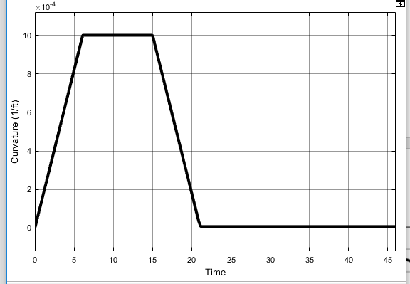

Figure 35 Road Curvature vs. Time

We can see in this plot that the road starts as straight with the curvature beginning at approximately zero. The road curvature then linearly increases until a road curvature of. Curvature is then held constant for a period of time. Curvature then starts to decrease until it is equal to approximately zero and then held constant for a period of time once again. This curvature plot is very representative of an AASHTO regulated road for a vehicle operating at 60 mph. This indicates that the vehicle is following the proper curvature trend of the roadway without any significant error or oscillatory nature indicating that the controller is capable of capable of controlling the vehicle with enough speed and accuracy.

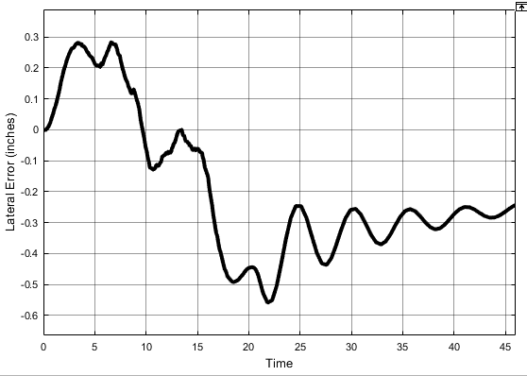

Figure 36 Lateral Deviation from Lane Center

Figure 36 shows the lateral deviation from the desired path which corresponds with the lane center of the given road. This is the first metric that is used to determine if the controller was successful. It can be seen in this plot that the vehicle maximum lateral deviation from the lane center was ###. This is well within the desired lateral error of 6 inches. Additionally the behavior of the curve itself indications that the lateral movement of the vehicle is stable and there are no excessive spikes or oscillations indicates the loss of control.

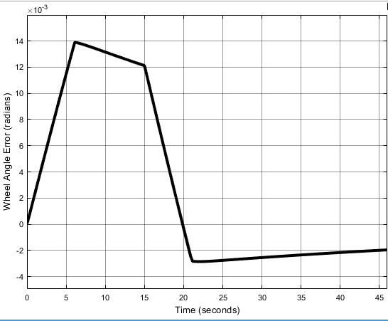

Figure 37 Wheel Angle Error from Current Desired Wheel Angle

The actual vehicle wheel angle was then compared to the ideal wheel angle. It should be noted that the ideal wheel angle is not equivalent to the desired wheel angle that is output from the PID controller as the controller creates a delay because a physical system cannot achieve a given value instantaneously.

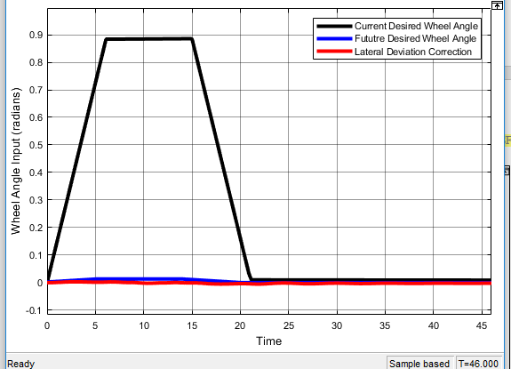

Figure 38 Wheel Angle Inputs

The desired wheel is the primary metric for keeping the vehicle on the target path, as mention before however, additional correction is still needed. The two supplementary controllers are used to supplement the control and increase the tracking accuracy of the vehicle. In Figure 38 the current wheel angle is the most dominant control input and the other inputs work to nudge the steering input in the correct direction to compensate for actual vehicle behavior.

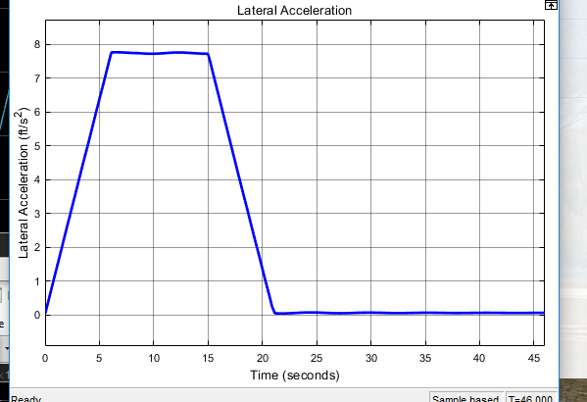

Figure Lateral Acceleration over Time

Lateral acceleration impacts vehicle stability and ride comfort. If lateral acceleration oscillates, the vehicle occupants will experience significant discomfort and will not adopt the autonomous system. Lateral acceleration oscillation can also instigate roll over instability as quick, significant directional changes in lateral acceleration cause the vehicle C.G. inertia to lag the friction development of the tires. Therefore it is important to minimize lateral acceleration oscillation. It can be seen in Figure 39 that lateral acceleration throughout the curve follows the expected acceleration according to without significant abnormalities indicating a smooth stable ride.

* + 1. Emergency Stop Control

As demonstrated in section 5.6, in order for an emergency stop to be executed by an ADAS that is not constantly in control of the vehicle, a steering correction is necessary to top the vehicle on the road. This control method is based on the vehicle control structure disclosed in section 5.9.3. This structure was implemented to stop the vehicle once the reached a lateral deviation of 6 ft from the desired path. The magnitude of error significantly affects the stability of the PID controller. The control need to be adjusted to compensate for this higher error so it doesn’t cause the vehicle to become unstable trying to correct itself. The tuned constants for the three controllers are shown in Table 2. When compared to the constant values in Table 1 the proportional gain for the desired wheel angle was reduced to slow the speed of the steering correction. The derivative constant was increased slightly to improve correction behavior.

Table Emergency Stop Control Parameters



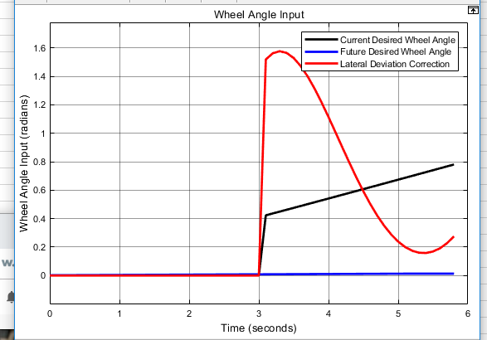

Figure Wheel Angle Inputs for Emergency Stop

Shown in Figure 40 are vehicle steering inputs. Unlike the previous model, the control is now dominated by the lateral error correction. This makes sense as the for a transition curve the difference in steering angle will not be very significant. This is the desired behavior for this scenario because the vehicle controller needs to make correcting the lateral deviation as the top priority in order to remain on the road.

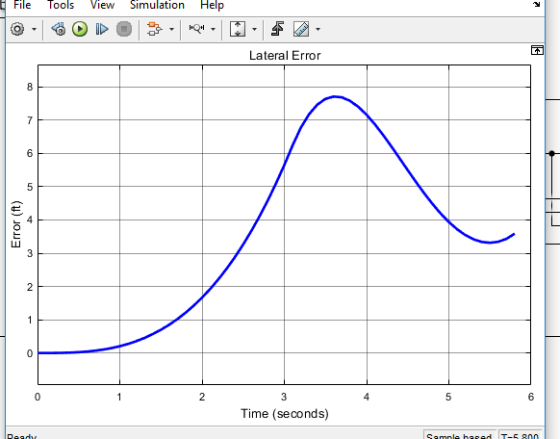

Figure Lateral Error during Emergency Stop

When the steering control is applied to the emergency stop the minimizing is clearly tremendously improved comparing Figure 26 and Figure 41. The vehicle still proceeds past the outer road edge by 1.7 ft which is not allowable in certain environments when the vehicle cannot cross over the road edge. Increasing the aggressiveness of controller to turn more quickly towards the roadway creates over shooting issues and therefore is not ideal. To properly prevent the road boundary additional metrics were discussed in previous sections of this report. These metric should be tested with a real driver to determine the impact they have on deterring road departures before a vehicle intervention is necessary.

1. SUMMARY AND FUTURE WORK
   1. Summary
      1. Path Generation

This section is focused on a technique for generating a discrete, curvature-dependent path from an offline database information such as GPS or geographical scans. The technique was developed from geometric formulations implemented from Google Earth data. The technique is further developed with AASHTO guidelines to increase accuracy and comply with dynamic tire limits. Results showed that this method provides a reasonable guidance heading angle for vehicles.

* + 1. Vehicle Control

In order to determine the feasibility of the proposed road data technique a control system was developed in two phases. The first phase was the use of the road data to develop potential thresholds for an ADAS whose operation is to waring the driver of unsafe driving behavior and safety stop the vehicle in the case of an imminent road departure. The metrics developed for departure warning were based on the following:

* Excessive Speed
* Roll Over Stability
* Heading Angle Error
* Lateral Acceleration
* Lateral Deviation

The impact of each of these thresholds were individually discussed for how they can contribute to a driver alert system and recommendations for threshold values were disclosed. Further evaluation, with live vehicle testing, is need to refine the recommended thresholds after accounting for real driver and vehicle handling behavior. The secondary part to the ADAS system was the discussion of necessities to govern an emergency vehicle stop in various scenarios. The active vehicle control in these scenarios was also developed in conjunction with autonomous control system.

In addition to developing departure warning characteristics a vehicle guidance structure was also developed to study the use of the proposed road data model for autonomous vehicle travel. Using the road data developed in Chapter 5, a multiple PID control structure was simulated for controlling a vehicle throughout an AASHTO regulated curve.

The disclosed vehicle control structure was able to adequately control the vehicle model throughout the entire curve stably with a maximum deviation from the target path of less than one inch, well within desired limits for vehicle travel to stay in lane. This control model can help provide a base point for live vehicle testing.

1. REFERENCES
2. United States Department of Transportation, Roadway Departure Safety, Available:<https://safety.fhwa.dot.gov/roadway_dept/>July 23, 2018.
3. Andrews, S., *Vehicle-to-Vehicle (V2V) and Vehicle-to-Infrastructure (V2I) Communications and Cooperative Drivering,* Handbook of Intelligent Vehicles, Eskandarian (ed), Springer-Verlag, London, 2012. DOI 10.1007/978-0-85729-085-4_46
4. *V2V/V2I Communications for Improved Road Safety and Efficiency*, Jurgen, R.K., (ed), Society of Automotive Engineers, Warrendale, PA, 2012. ISBN 978-0-7680-7725-4
5. Devilly, O., and O’Mahony, M., *Assessing the Benefits of Installing V2I Communications on an Urban Orbital Motorway in a Medium Sized European City*, Journal of the Transportation Research Board, Washington, D.C., January 2018
6. *SAE International, Surface Vehicle Recommended Practice J3016,* June 2018.
7. Sweigard, M.E., Jacome, R.O., and Stolle, C.S., *MATC Year One Report, Final Report to Mid-America Transportation Center*, MwRSF Research Report No. MwRSF-40042-01, University of Nebraska-Lincoln, Lincoln, Nebraska, October 2018.
8. GPS.GOV, GPS Accuracy, Available: <<https://www.gps.gov/systems/gps/performance/accuracy/>> 09/18/2019
9. Computerworld, Black Hat Europe: It’s easy and costs only $60 to hack self-driving car sensors, Avaiblable: <<https://www.computerworld.com/article/3005436/black-hat-europe-it-s-easy-and-costs-only-60-to-hack-self-driving-car-sensors.html>> 09/18/2019
10. M. Werling, J. Ziegler, K. Soren, and S. Thrun*. Optimal Trajectory Generation for Dynamic Street Scenarios in a Frenet Frame*, 2010
11. A. Kelly, B. Nagy, *Reactive Nonholonomic Trajectory Generation via Parametric Optimal Control*, 2003
12. Y. Sun, Z. Zhan, Y. Fang, L. Zheng, L. Wang, G. Guo, *A Dynamic Local Trajectory Planning and Tracking Method for UGV Based on Optimal Algorithm*, 2019
13. A. Takahashi, T. Hongo, Y. Ninomiya, G. Sugimoto, *Local Path Planning and Motion Control for AGV in Positioning*, 1989
14. A. Piazzi, C. Guarino lo Bianco*, Quintic G2-Splines for Trajectory Planning of Autonomous Vehicles*, 2000
15. D. Wilde, *Computing Clothoid-Arc Segments for Trajectory Generation*, 2009
16. H. Delingette, M. Hebert, K. Ikeuchi, *Trajectory Generation with Curvature Constraint based on Energy Minimization*, 1991
17. L. J. van Vliet, P. W. Verbeek, *Curvature and Bending Energy in Digitized 2D and 3D Images*, 1993
18. P. Guillaume, J. Schoukens, R. Pintelon, *Sensitivity of Roots to Errors in the Coefficient of Polynomials Obtained by Frequency –Domain Estimation Methods*, 1989
19. K. E. Atkinson, *An Introduction to Numerical Analysis*, 1989
20. O. M. O’Reilly, *Engineering Dynamics A Primer*, 2010
21. A.N. Pressley, *Elementary Differential Geometry*, 2010
22. H. B. Pacejka, *Tyre and Vehicle Dynamics*, 2006
23. T. D. Gillespie, *Fundamentals of Vehicle Dynamics*, 1992
24. M. P. do Carmo, *Differential Geometry of Curves and Surfaces*, 1976
25. *AASHTO, A Policy on Geometric Design of Highways and Streets*, 2011
26. A. Mjaavatten, *Curvature of a Discrete Curve in 3D Space*, 2018
27. M. Duhn, G. Parikh, J. Hourdos, *I-94 Connected Vehicles Testbed Operations and Maintenance*, 2019
28. Druta, A. S. Alden*, Implementation and Evaluation of a Buried Cable Animal Detection System and Deer Warning Sign*, 2019
29. SAE International, *J3016-Taxonomy and Definitions for Terms Related to Driving Automation Systems for On-Road Motor Vehicles*, 2018
30. William J. Hughes Technical Center, *Global Positioning System (GPS) Standard Positioning Service (SPS) Performance Analysis Report*, 2017
31. S. Heinrich, *Planning Universal On-Road Driving Strategies for Automated Vehicles*, 2018
32. *Model S Owner’s Manual*, Tesla Inc., May 2019
33. *Accord 2018 Owner’s Manual*, Honda Motor Company, December 2017..
34. *Toyota 2018 Camry From July 2017 Prod. Owner’s Manual (OM06122U)*, Toyota Motor Corporation, July 2017.
35. *2018 Altima Sedan Owners’ Manual and Maintenance Information,* Nissan Motor Company, November 2017.
36. *2018 Malibu Owner’s Manual*, General Motors, Plymouth, MI, 2017.
37. 2019 Fusion Owner’s Manual, Ford Motor Company, 2018.
38. Jung, C. R., and Kelber, C. R., *A Lane Departure Warning System on A Linear- Parabolic Lane Model*, 2004 IEEE Intelligent Vehicles Symposium, Parma, Italy, June 2004, pages 891-895.
39. Jung, C. R., and Kelber, C. R., *A Lane Departure Warning System Using Lateral Offset with Uncalibrated Camera*, October 2005.
40. Somasundaram, G., Kavitha, and Ramachandran, K. I., Lane Change Detection and Tracking for a Safe-Lane Approach in Real Time Vision Based Navigation Systems, First Interantional Conference On Computer Science, Engineering And Applications 2011, Chennai, India, 2011, pages 345-361.
41. Kwon, W., and Lee, S., *Performance Evaluation of Decision Making Strategies for an Embedded Lane Departure Warning System*, Journal of Robotic Systems 19(10), 2002, pages 499-509.
42. Clanton, J. M., Bevly, D. M., and Hodel, A. S., *A Low-Cost Solution for an Integrated Multisensor Lane Departure Warning System*, IEEE Transaction on Intelligent Transpiration Systems, Vol. 10, No. 1, March 2009, pages 47-59.
43. Faizan, M., Hussain, S., and Hayee, M. I., *Design and Development of In-Vehicle Lane Departure Warning System using Standard Global Positioning System Receiver*, Journal of the Transportation Research Board, 2019.
44. Wang, J., Schroedl, S., Mezger, K., Ortloff, R., and Joos, A., and Passegger, T*., Lane Keeping Based on Location Technology*, IEEE Transaction on Intelligent Transportation Systems, Vol. 6. No.3, September 2005, pages 351-356
45. Heimes, F., and Nagel, H. H., *Towards Active Machine-Vision-Based Driver Assistance for Urban Areas*, International Journal of Computer Vision 50(1) 2002, pages 5-34.
46. Goldbeck, J., Huertgen, B., Ernst, S., and Kelch, L*., Lane Following Combining Vision and DGPS,* Image and Vision Computing 18, 2000 pages 425-433.
47. NHSTA SOURCE
48. Contorls Turorials for MATLAB & SIMULINK, Introduction: PID Controller Design, Available: <<http://ctms.engin.umich.edu/CTMS/index.php?example=Introduction&section=ControlPID>> 09/19/2019
49. MathWorks, Understanding Model Predictive Control, Available: <<https://www.mathworks.com/videos/understanding-model-predictive-control-part-1-why-use-mpc--1526484715269.html>> 09/19/2019
50. Standalone Power Converter, Report 2 , Available: <<https://www.cefns.nau.edu/capstone/projects/EE/2018/OffgridConverter/report_2.html>> 09/19/2019
51. Snider, J. M., *Automatic Steering Methods for Autonomous Automobile Path Tracking*, CMU-RI_TR_09-08, Robotics Institute Carnegie Mellon University, Pittsburgh, PA, February 2009.
52. MathWorks, Pure Pursuit Controller, Available: <<https://www.mathworks.com/help/robotics/ug/pure-pursuit-controller.html>> 09/19/2019
53. Gillespi, T. D., Fundamentals of Vehicle Dynamics, SAE International, February 1992
54. APPENDICES
55. Euler-Lagrange General Formulation

*Find a function such that the functional is stationary (is minimized or maximized). Along with boundary conditions of the form and.*

Let be a solution that makes stationary and satisfies boundary conditions.

Introduce: = Arbitrary Function & (1)

Define:

Where:

= Variation of Variable

= A function that makes stationary

= Arbitrary function dependent on

= Small variation coefficient

Proof that Equation (1) satisfies the same Boundary Conditions as problem statement:

Applying Boundary Conditions (1) into Equation (1) the problem simplifies to the original problem.

Thus, solving for is sufficient to solve for. E.O.M.

Through introduction of Equation (2), it is possible to change the problem from solving for to solving for. Thus, turning the problem in the following form:

*Find a function (or family of functions) which makes the new functional stationary.*

Given that Equation (2) makes dependent on, the integral of will provide a functional that only depends on. For this reason, it is possible to make an optimization problem by setting:

In optimization problems, it is necessary to evaluate the function (or functional) at an extrema point. For this situation, can be evaluated at zero, which will provide an extrema as follows:

Provided the assumption of is a solution that makes is stationary. By setting to zero, the functional has been optimized.

To evaluate this expression, the definition of is used which gives an integral equation to solve:

By replacing & using the Chain Rule:

Remark of Equation (2) and its derivatives:

Plugging those into Equation (4):

Splitting the integral into its two constituents, the second term can be simplified using integration by parts:

By definition:

Applying boundary conditions (1) for limit on the left term

Plugging Equation (6) back into Equation (5)

From Equation (2), it was stated that setting yields, which was defined as an optimal solution for the functional. Thus, setting into Equation (7):

Grouping similar terms, and expressing as an arbitrary function of:

This final equation is a product in between an arbitrary function and a functional. Therefore, for the Equation (9) to be true for any arbitrary. The following has to be true:

Therefore: If makes stationary, then must satisfy the previous equation know as Euler-Lagrange Equation.

END of Document